**RT- CPV- AFA / 2020 Nº 07**

MAPEAMENTO TERMOGRÁFICO DO CONJUNTO PORTA VENTO - AFA

**1 - OBJETIVO**

Este relatório visa apresentar o perfil térmico superficial dos Conjuntos Porta Vento, através da inspeção termográfica das paredes externas dos mesmos.

**2 - INSTRUÇOES DE TRABALHO**

2.1- Instruções de trabalho desenvolvidas e validadas pela Manserv Industrial, através de seu sistema de gestão da qualidade e normas internas de segurança;

2.2 - Procedimentos operacionais e normas internas de segurança da ArcelorMittal Monlevade;

2.3 - Normas e padrões de temperaturas máximas admissíveis para equipamentos e componentes, segundo seus fabricantes;

2.4 - Utilizamos emissividade de 0.92 como padrão em todas as tomadas termográficas efetuadas nesta inspeção.

**3 - ATIVIDADES REALIZADAS**

No dia 28 de setembro de 2020, foi realizado mapeamento térmico na estrutura externa do conjunto porta vento, (Saída Porta Vento/Avião, Down Leg e Algaraviz Joelho e Algaraviz Nariz).

**4 - DADOS OPERACIONAIS E AMBIENTAIS**

Durante todo o mapeamento termográfico a temperatura de sopro manteve-se em 1104ºC e a vazão de ar em 129840 Nm3/h. A temperatura ambiente média foi de 28ºC; velocidade do vento 0,2 m/s

**5 - OBSERVAÇÕES DA INSPEÃO**

5.3. As seguintes peças encontravam-se com refrigeração forçada a ar comprimido:

**SAÍDA PORTA VENTO:**

VT 06;

**ALGARAVIZ (NARIZ):**

VT 03/NR M159; VT 04/NR M167; VT 05/NR M101; VT 06/NR 32 M119; VT 08/NR M132; VT 09/NR 11; VT 10/NR M164; VT 11/NR M165; VT 12/NR M168; VT 11/NR M165; VT 13/NR M123; VT 15/NR M156; VT 16/NR M163; VT 17/NR 24 M114; VT 18/NR 15 M129; VT 19/NR M154; VT 20/NR M160; VT 21/NR M162; VT 22/NR M155

A Manserv Industrial agradece a preferência, e coloca-se ao inteiro dispor para todos os esclarecimentos que se fizerem necessário.

Atenciosamente,

Gilmar Cristino Campos Júnior Executante Técnico



Fabricio Ezequiel Marçal Executante Técnico

Jaderson Tiago Gonçalves Supervisor de Operação Termografia / SPCI



MAPAS TÉRMICOS – SAÍDA PORTA VENTO

**MAPEAMENTO TÉRMICO – SAÍDA PORTA VENTO**

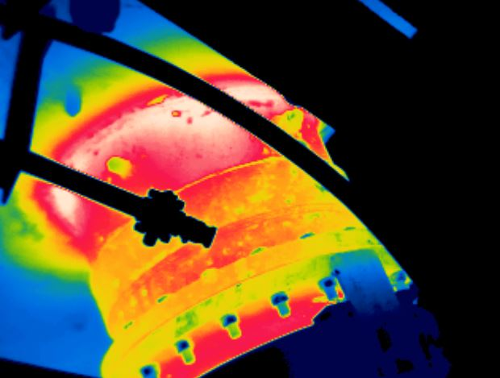

# **VT03 / LD**

**20/01/2021**

# **MAX= 172ºC**

**12:57:26**

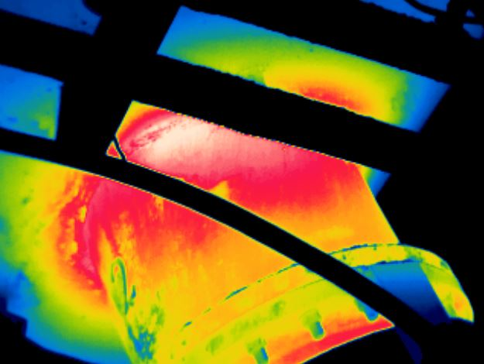

# **VT02 / LD**

**20/01/2021**

# **MAX= 171ºC**

**12:57:18**

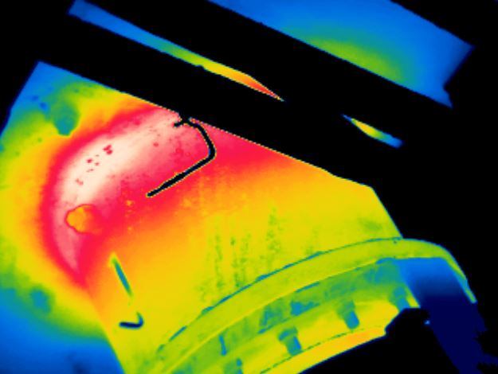

# **VT01 / LD**

**20/01/2021**

# **MAX= 191ºC**

**12:57:06**

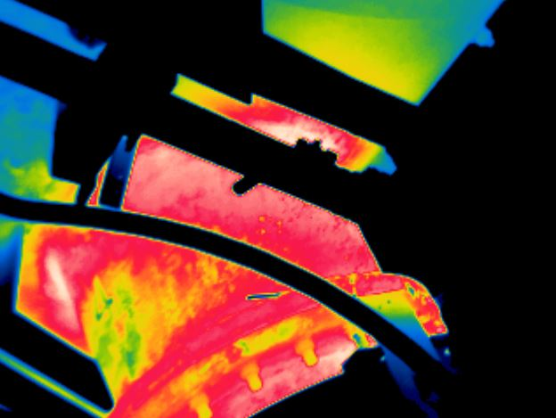

# **VT04 / LD**

**20/01/2021**

# **MAX= 156ºC**

**12:57:40**

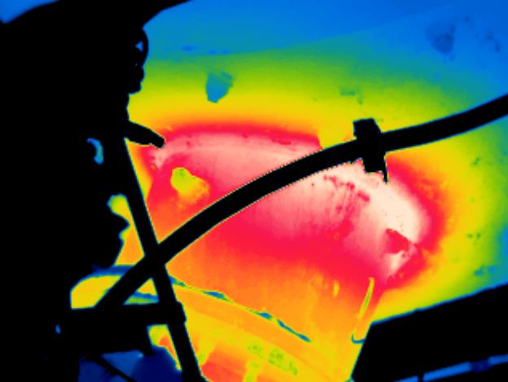

# **VT01 / LE**

**20/01/2021**

# **MAX= 189ºC**

**12:57:12**

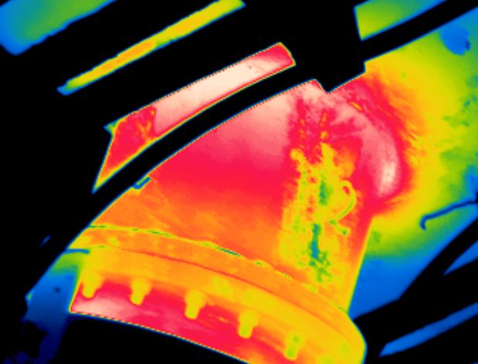

# **VT02 / LE**

**20/01/2021**

# **MAX= 170ºC**

**12:57:22**

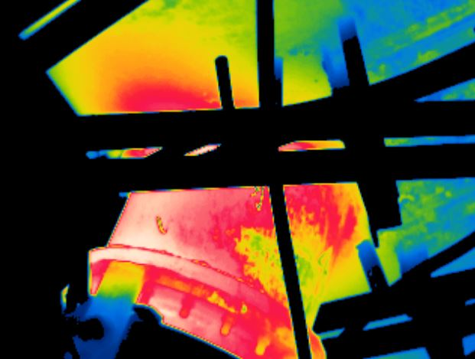

# **VT04 / LE**

**20/01/2021**

# **MAX= 168ºC**

**12:57:46**

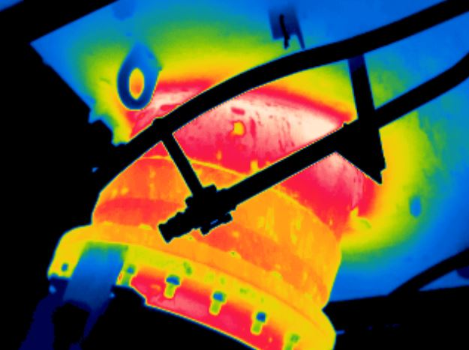

# **VT03 / LE**

**20/01/2021**

# **MAX= 173ºC**

**12:57:32**

**MAPEAMENTO TÉRMICO – SAÍDA PORTA VENTO**

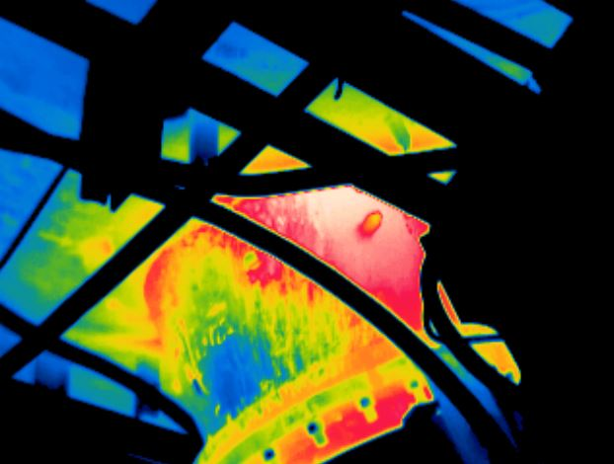

# **VT07 / LD**

**20/01/2021**

# **MAX= 168ºC**

**12:58:18**

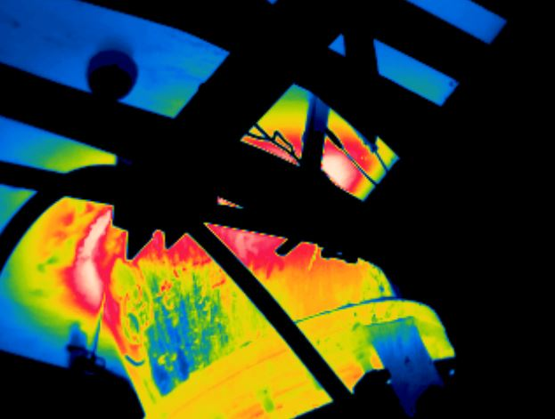

# **VT06 / LD**

**20/01/2021**

# **MAX= 189ºC**

**12:58:08**

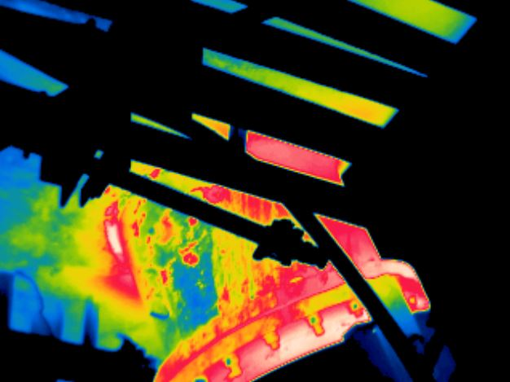

# **VT05 / LD**

**20/01/2021**

# **MAX= 178ºC**

**12:57:54**

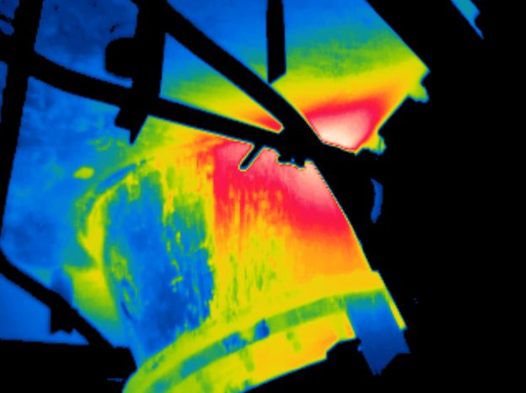

# **VT08 / LD**

**20/01/2021**

# **MAX= 210ºC**

**12:58:30**

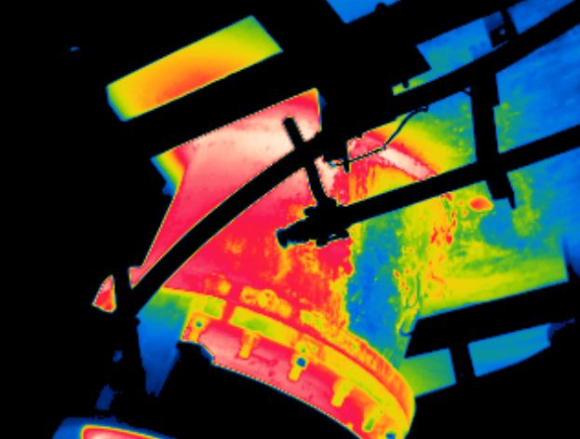

# **VT05 / LE**

**20/01/2021**

# **MAX= 188ºC**

**12:58:02**

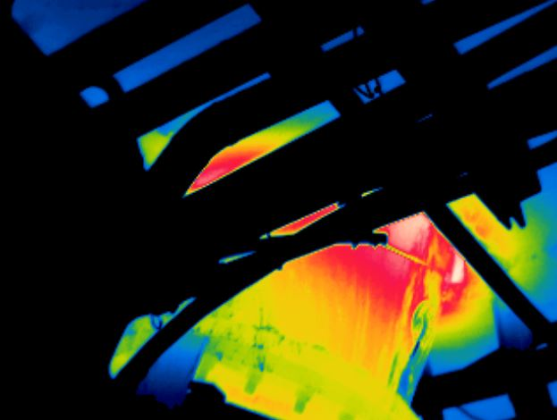

# **VT06 / LE**

**20/01/2021**

# **MAX= 187ºC**

**12:58:14**

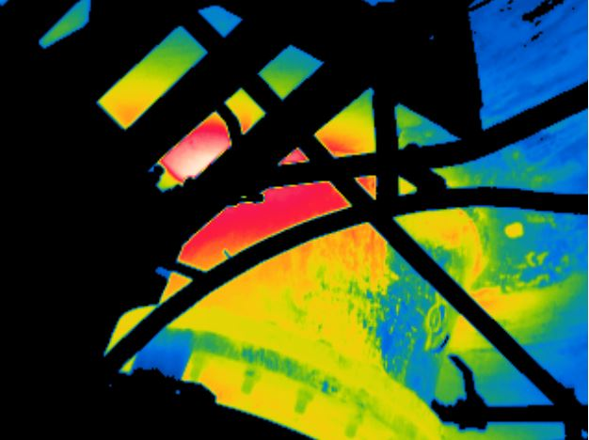

# **VT08 / LE**

**20/01/2021**

# **MAX= 215ºC**

**12:58:36**

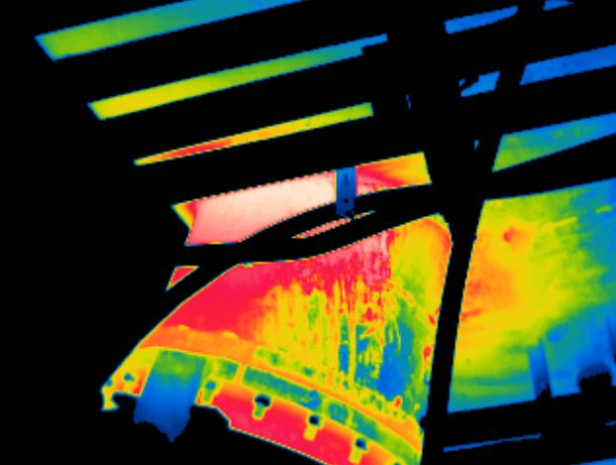

# **VT07 / LE**

**20/01/2021**

# **MAX= 164ºC**

**12:58:26**

**MAPEAMENTO TÉRMICO – SAÍDA PORTA VENTO**

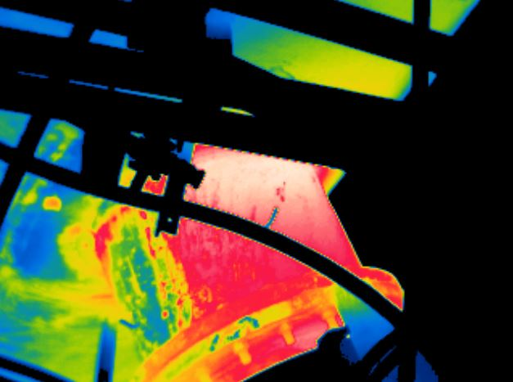

# **VT11 / LD**

**20/01/2021**

# **MAX= 154ºC**

**12:59:08**

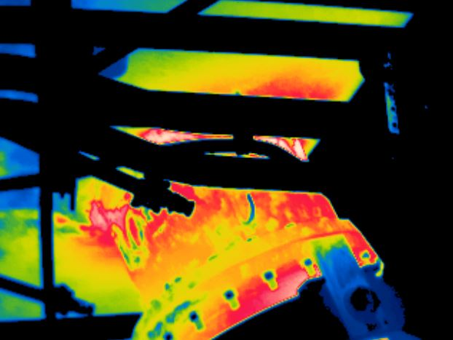

# **VT10 / LD**

**20/01/2021**

# **MAX= 149ºC**

**12:58:56**

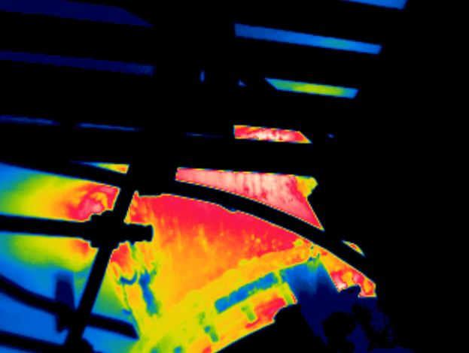

# **VT09 / LD**

**20/01/2021**

# **MAX= 145ºC**

**12:58:42**

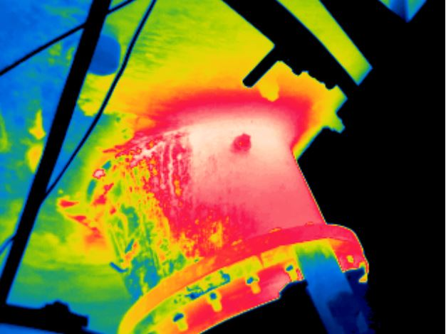

# **VT12 / LD**

**20/01/2021**

# **MAX= 155ºC**

**12:59:20**

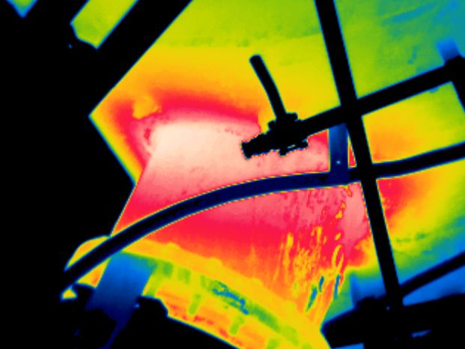

# **VT09 / LE**

**20/01/2021**

# **MAX= 146ºC**

**12:58:50**

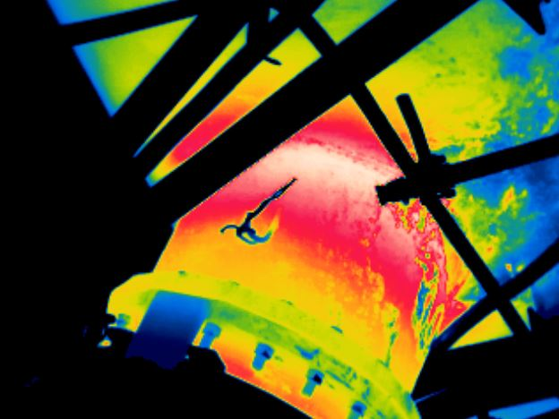

# **VT10 / LE**

**20/01/2021**

# **MAX= 151ºC**

**12:59:02**

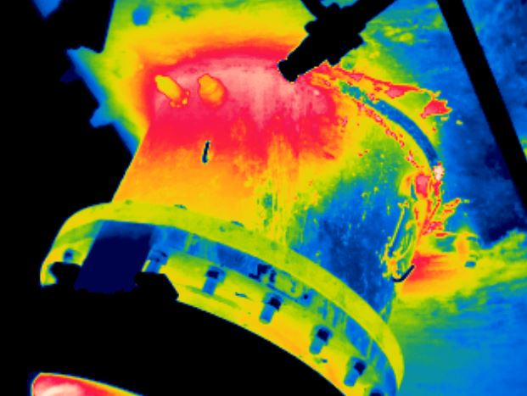

# **VT12 / LE**

**20/01/2021**

# **MAX= 147ºC**

**12:59:28**

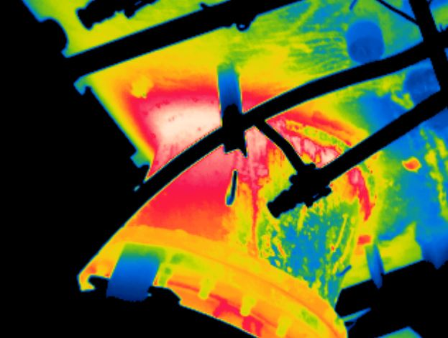

# **VT11 / LE**

**20/01/2021**

# **MAX= 150ºC**

**12:59:14**

**MAPEAMENTO TÉRMICO – SAÍDA PORTA VENTO**

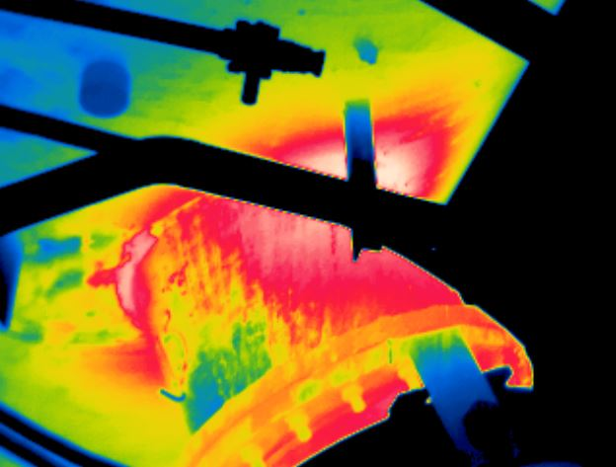

# **VT15 / LD**

**20/01/2021**

# **MAX= 155ºC**

**13:00:00**

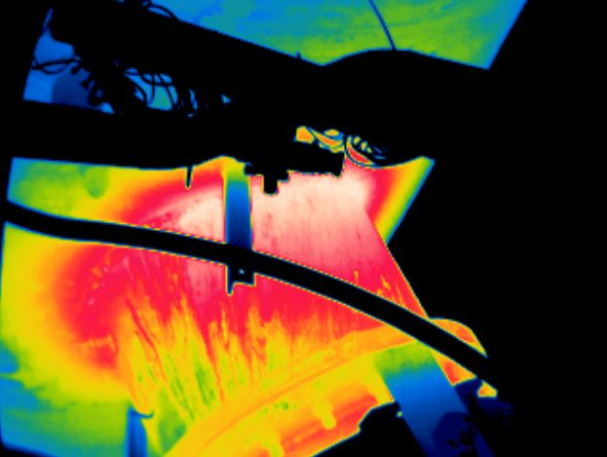

# **VT14 / LD**

**20/01/2021**

# **MAX= 165ºC**

**12:59:46**

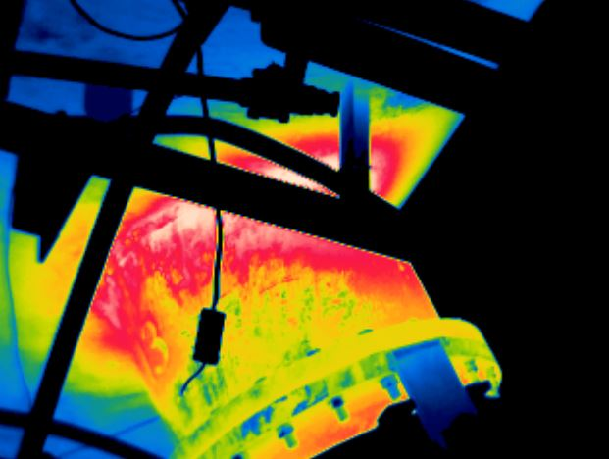

# **VT13 / LD**

**20/01/2021**

# **MAX= 160ºC**

**12:59:34**

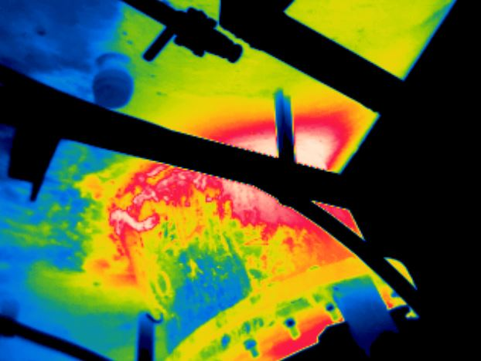

# **VT16 / LD**

**20/01/2021**

# **MAX= 151ºC**

**13:00:12**

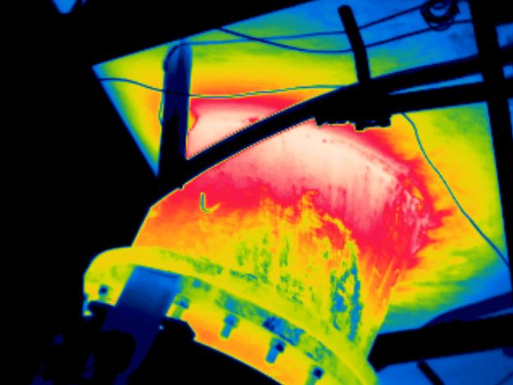

# **VT13 / LE**

**20/01/2021**

# **MAX= 159ºC**

**12:59:42**

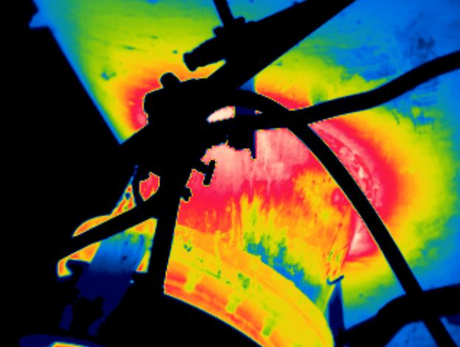

# **VT14 / LE**

**20/01/2021**

# **MAX= 155ºC**

**12:59:54**

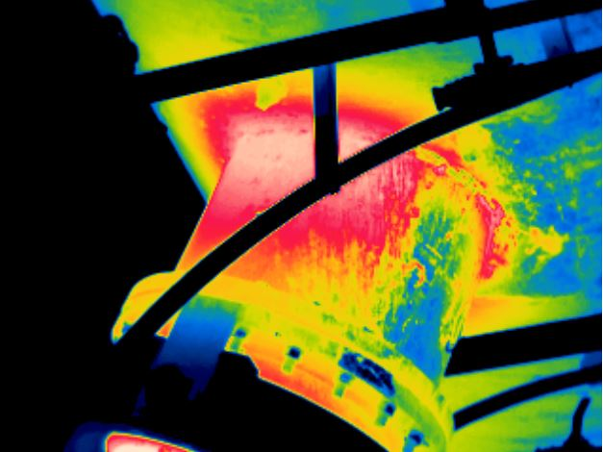

# **VT16 / LE**

**20/01/2021**

# **MAX= 152ºC**

**13:00:20**

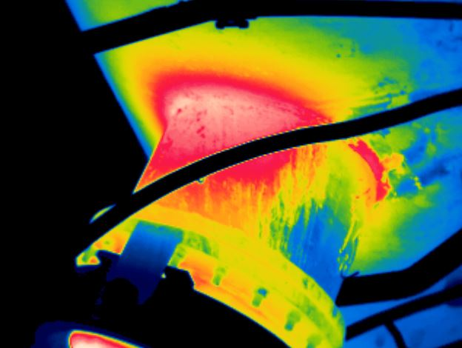

# **VT15 / LE**

**20/01/2021**

# **MAX= 160ºC**

**13:00:06**

**MAPEAMENTO TÉRMICO – SAÍDA PORTA VENTO**

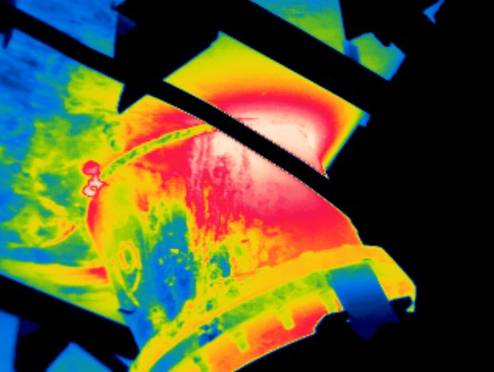

# **VT19 / LD**

**20/01/2021**

# **MAX= 163ºC**

**13:00:50**

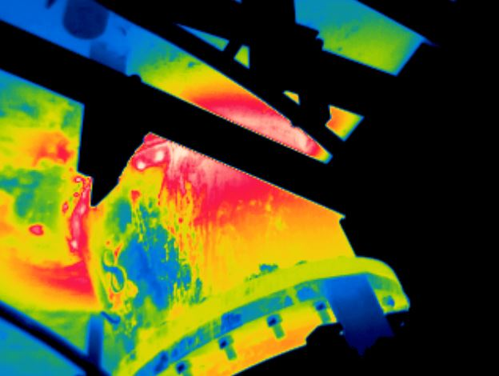

# **VT18 / LD**

**20/01/2021**

# **MAX= 168ºC**

**13:00:38**

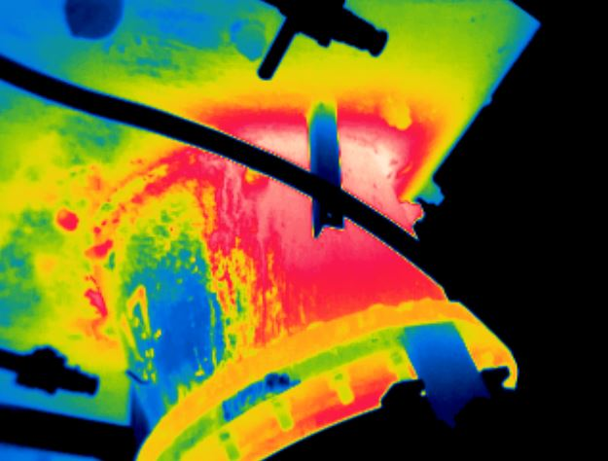

# **VT17 / LD**

**20/01/2021**

# **MAX= 157ºC**

**13:00:24**

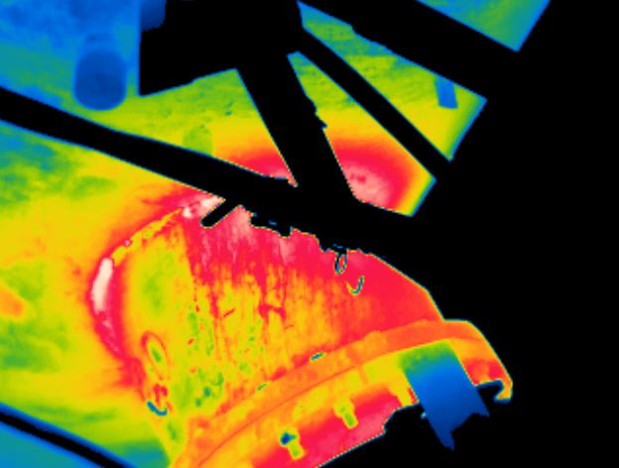

# **VT20 / LD**

**20/01/2021**

# **MAX= 157ºC**

**13:01:02**

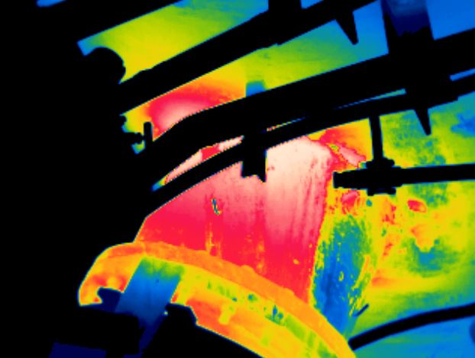

# **VT17 / LE**

**20/01/2021**

# **MAX= 152ºC**

**13:00:32**

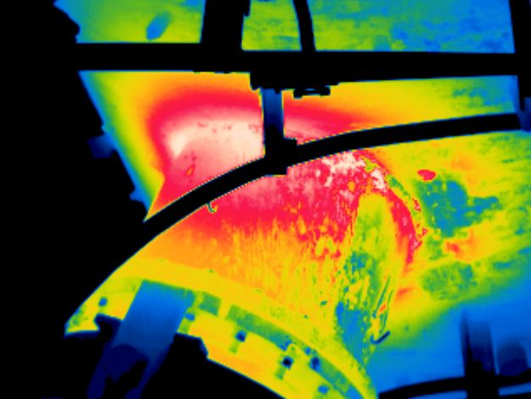

# **VT18 / LE**

**20/01/2021**

# **MAX= 174ºC**

**13:00:44**

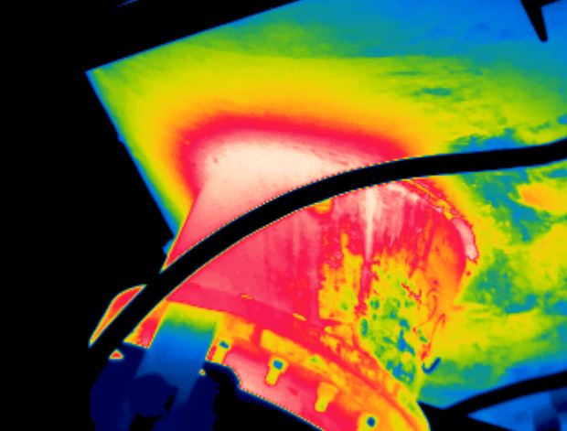

# **VT20 / LE**

**20/01/2021**

# **MAX= 199ºC**

**13:01:10**

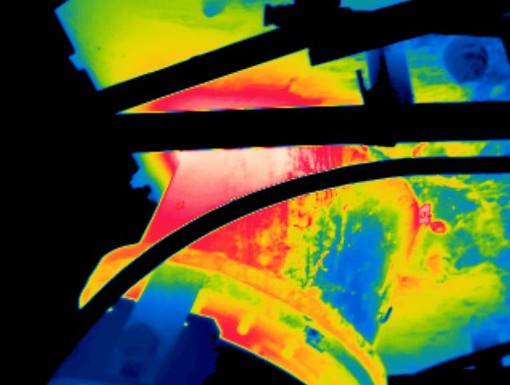

# **VT19 / LE**

**20/01/2021**

# **MAX= 174ºC**

**13:00:56**

**MAPEAMENTO TÉRMICO – SAÍDA PORTA VENTO**

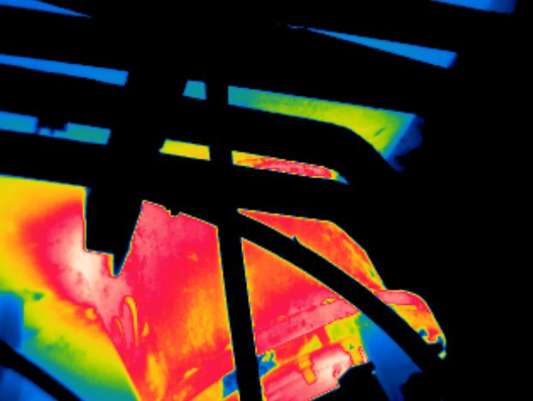

# **VT22 / LD**

**20/01/2021**

# **MAX= 165ºC**

**13:01:28**

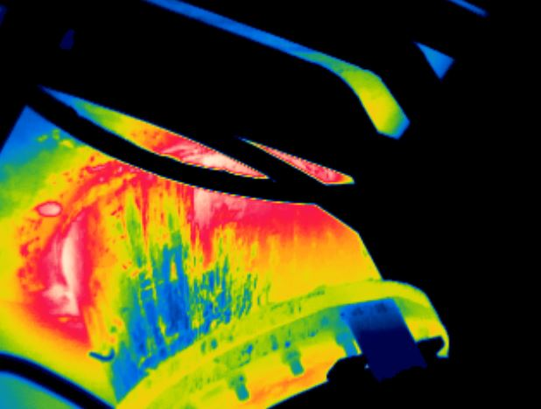

# **VT21 / LD**

**20/01/2021**

# **MAX= 161ºC**

**13:01:14**

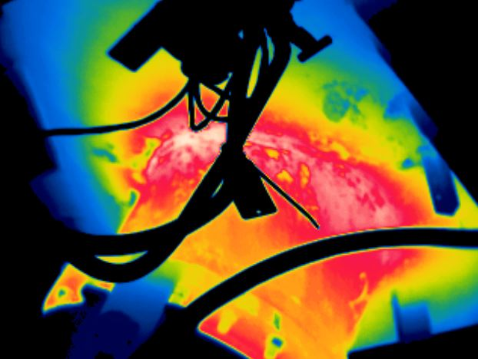

# **VT22 / LE**

**20/01/2021**

# **MAX= 179ºC**

**13:01:34**

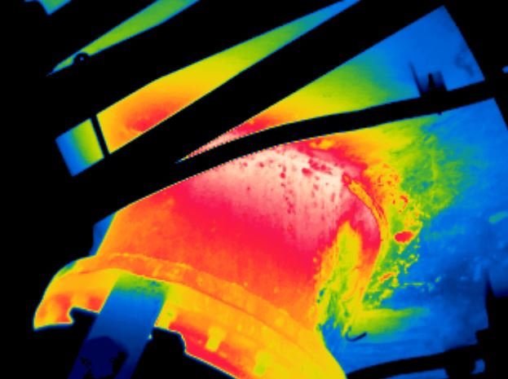

# **VT21 / LE**

**20/01/2021**

# **MAX= 167ºC**

**13:01:22**

MAPAS TÉRMICOS – DOWN LEG

**MAPEAMENTO TÉRMICO – DOWNLEG**

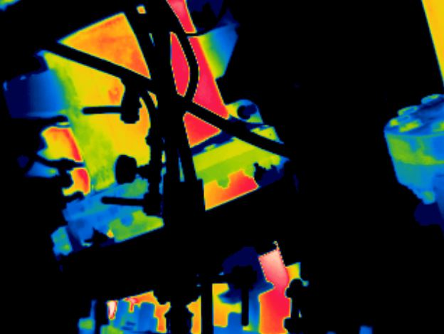

# **VT04 - DL XX / LD**

**20/01/2021**

# **MAX= 176ºC**

**13:03:58**

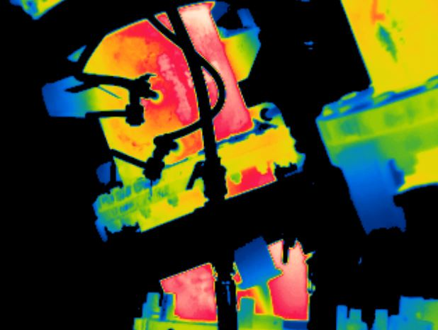

# **VT03 - DL XX / LD**

**20/01/2021**

# **MAX= 188ºC**

**13:03:36**

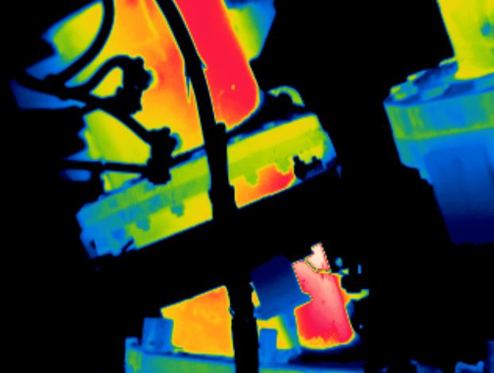

# **VT02 - DL XX / LD**

**20/01/2021**

# **MAX= 198ºC**

**13:03:04**

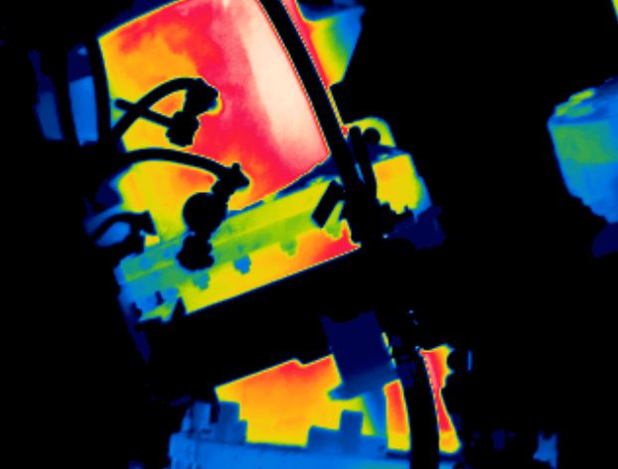

# **VT01 - DL XX / LD**

**20/01/2021**

# **MAX= 198ºC**

**13:01:46**

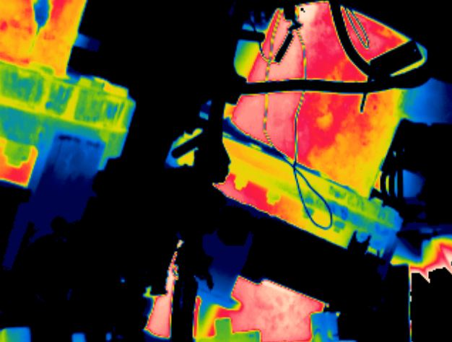

# **VT04 - DL XX / LE**

**20/01/2021**

# **MAX= 176ºC**

**13:04:08**

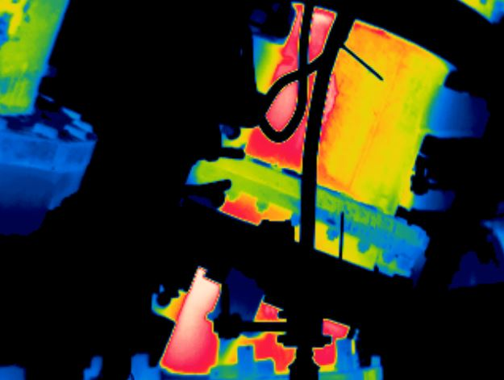

# **VT03 - DL XX / LE**

**20/01/2021**

# **MAX= 189ºC**

**13:03:46**

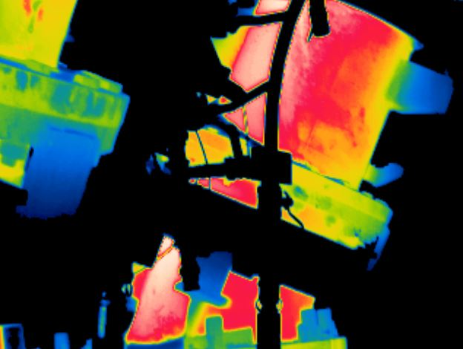

# **VT02 - DL XX / LE**

**20/01/2021**

# **MAX= 188ºC**

**13:03:22**

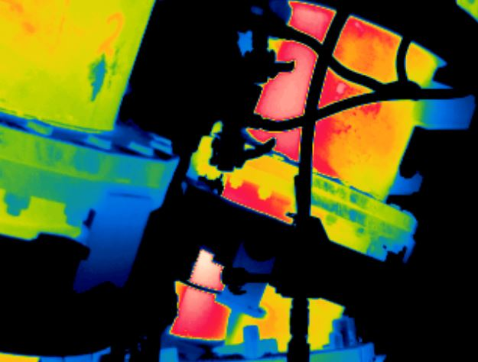

# **VT01 - DL XX / LE**

**20/01/2021**

# **MAX= 200ºC**

**13:02:14**

**MAPEAMENTO TÉRMICO – DOWNLEG**

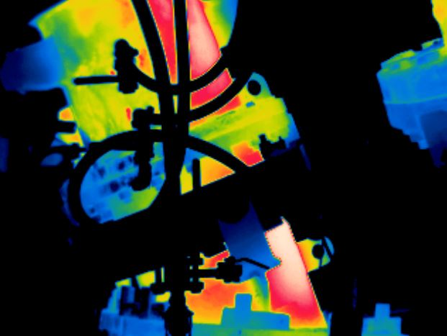

# **VT08 - DL XX / LD**

**20/01/2021**

# **MAX= 172ºC**

**13:05:10**

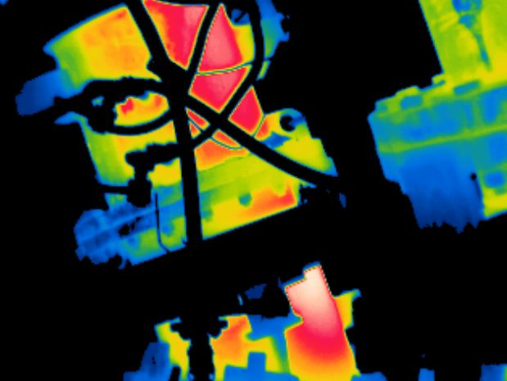

# **VT07 - DL XX / LD**

**20/01/2021**

# **MAX= 188ºC**

**13:04:50**

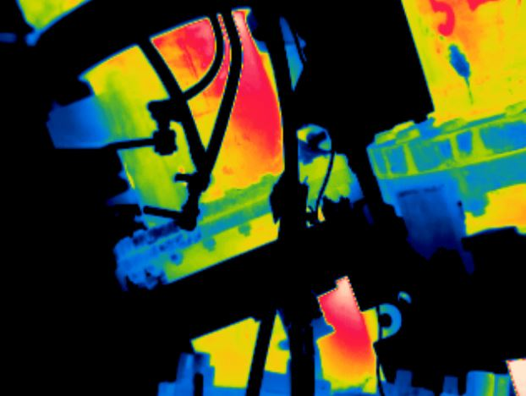

# **VT06 - DL XX / LD**

**20/01/2021**

# **MAX= 189ºC**

**13:04:32**

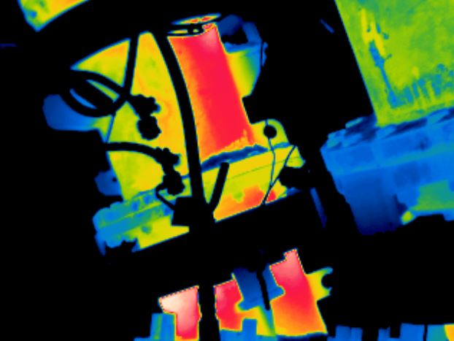

# **VT05 - DL XX / LD**

**20/01/2021**

# **MAX= 215ºC**

**13:04:16**

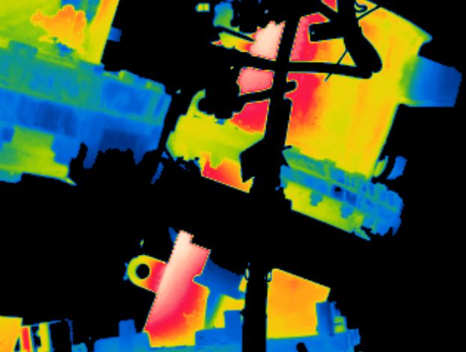

# **VT08 - DL XX / LE**

**20/01/2021**

# **MAX= 163ºC**

**13:05:22**

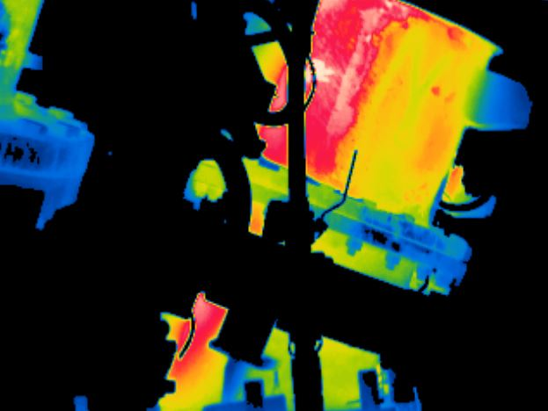

# **VT07 - DL XX / LE**

**20/01/2021**

# **MAX= 174ºC**

**13:05:00**

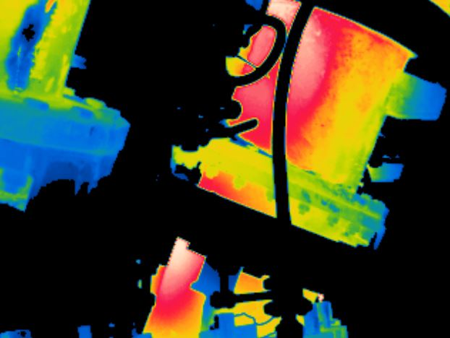

# **VT06 - DL XX / LE**

**20/01/2021**

# **MAX= 189ºC**

**13:04:42**

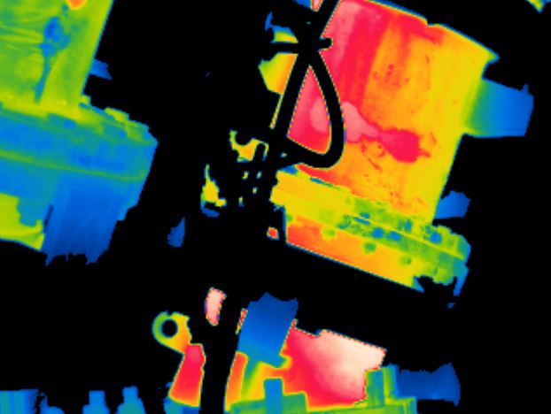

# **VT05 - DL XX / LE**

**20/01/2021**

# **MAX= 205ºC**

**13:04:24**

**MAPEAMENTO TÉRMICO – DOWNLEG**

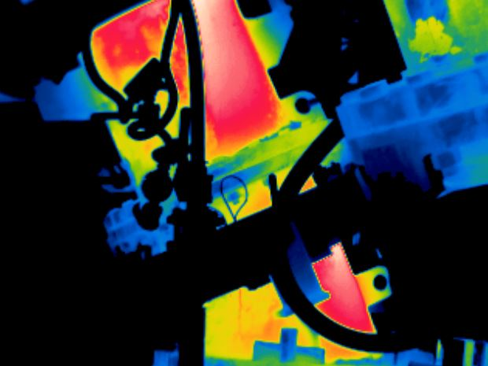

# **VT10 - DL XX / LD**

**20/01/2021**

# **MAX= 177ºC**

**13:05:46**

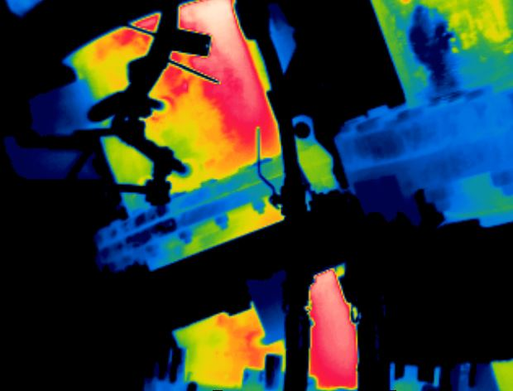

# **VT09 - DL XX / LD**

**20/01/2021**

# **MAX= 176ºC**

**13:05:30**

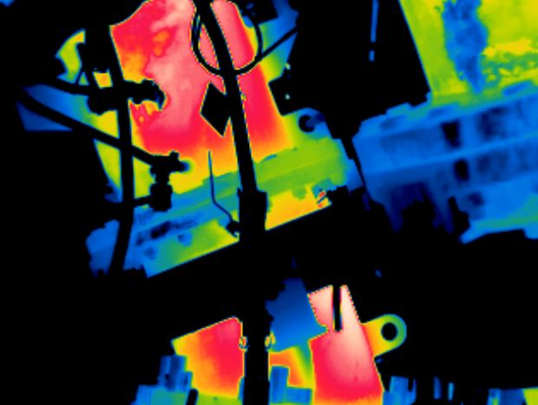

# **VT11 - DL XX / LD**

**20/01/2021**

# **MAX= 178ºC**

**13:06:04**

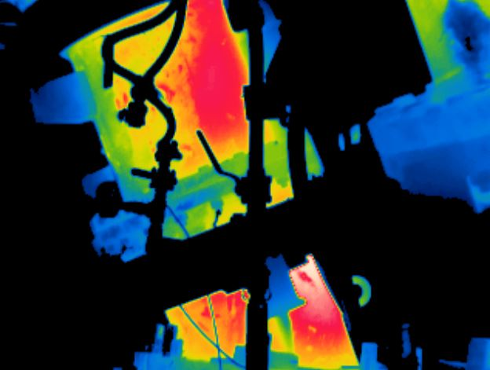

# **VT12 - DL XX / LD**

**20/01/2021**

# **MAX= 187ºC**

**13:06:18**

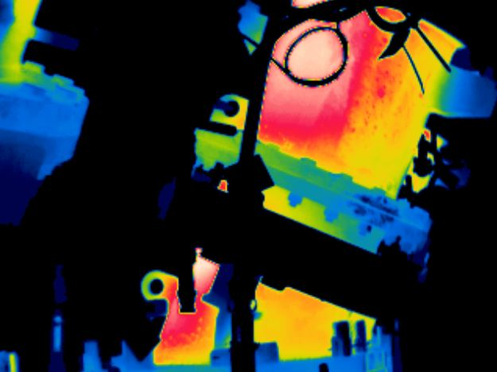

# **VT10 - DL XX / LE**

**20/01/2021**

# **MAX= 165ºC**

**13:05:56**

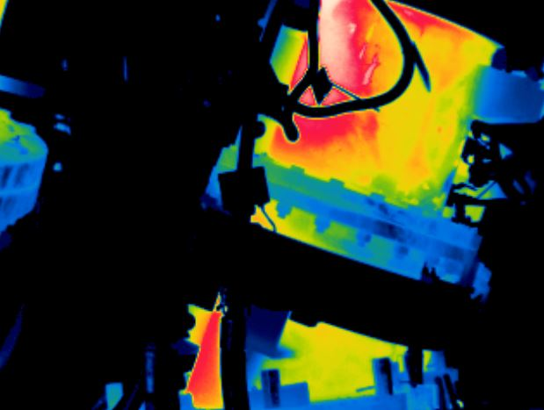

# **VT09 - DL XX / LE**

**20/01/2021**

# **MAX= 171ºC**

**13:05:38**

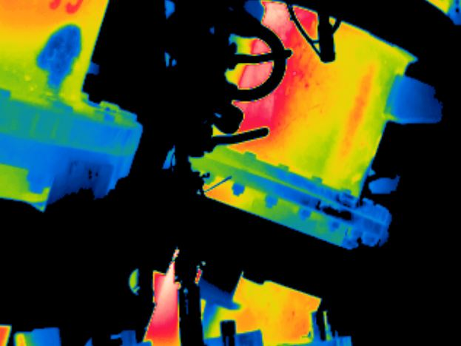

# **VT12 - DL XX / LE**

**20/01/2021**

# **MAX= 171ºC**

**13:06:30**

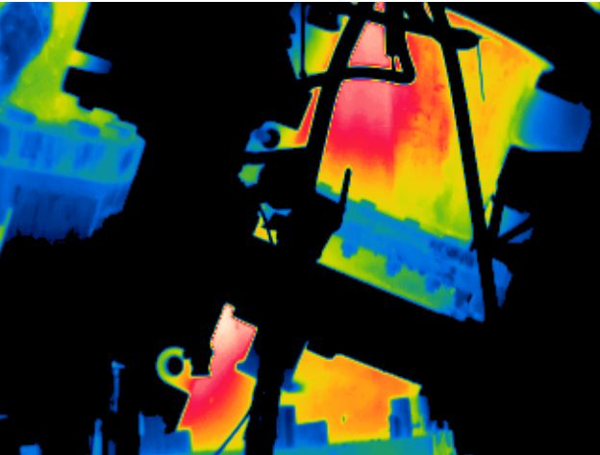

# **VT11 - DL XX / LE**

**20/01/2021**

# **MAX= 169ºC**

**13:06:12**

**MAPEAMENTO TÉRMICO – DOWNLEG**

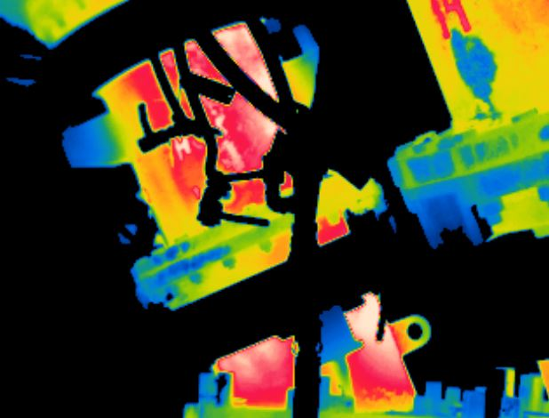

# **VT15 - DL XX / LD**

**20/01/2021**

# **MAX= 166ºC**

**13:07:44**

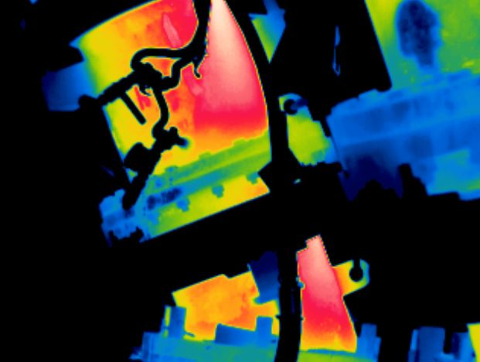

# **VT14 - DL XX / LD**

**20/01/2021**

# **MAX= 179ºC**

**13:06:54**

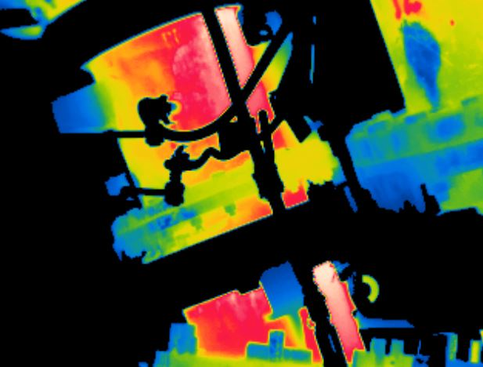

# **VT13 - DL XX / LD**

**20/01/2021**

# **MAX= 169ºC**

**13:06:38**

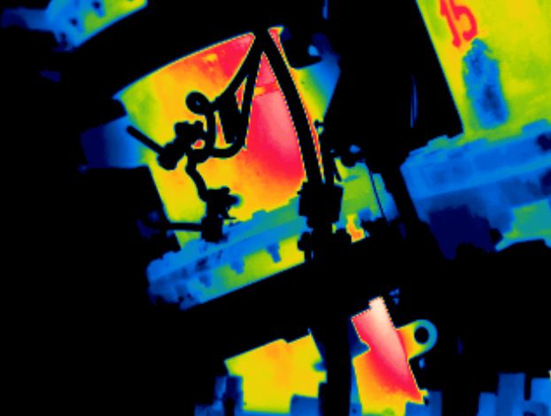

# **VT16 - DL XX / LD**

**20/01/2021**

# **MAX= 174ºC**

**13:08:04**

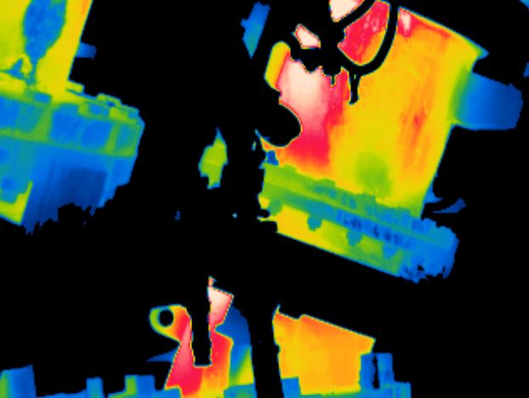

# **VT13 - DL XX / LE**

**20/01/2021**

# **MAX= 173ºC**

**13:06:46**

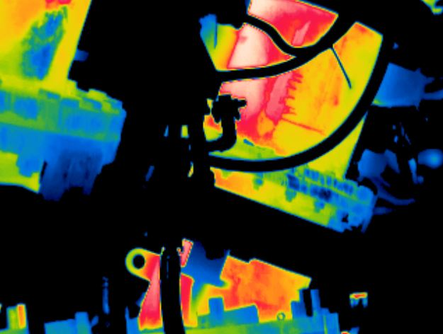

# **VT14 - DL XX / LE**

**20/01/2021**

# **MAX= 169ºC**

**13:07:06**

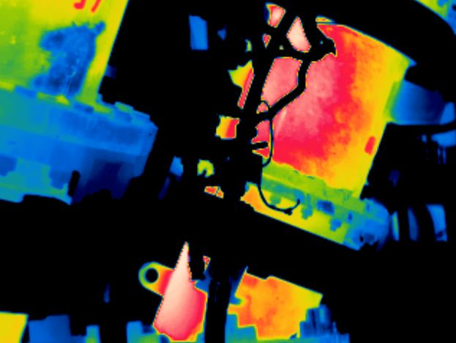

# **VT16 - DL XX / LE**

**20/01/2021**

# **MAX= 172ºC**

**13:08:12**

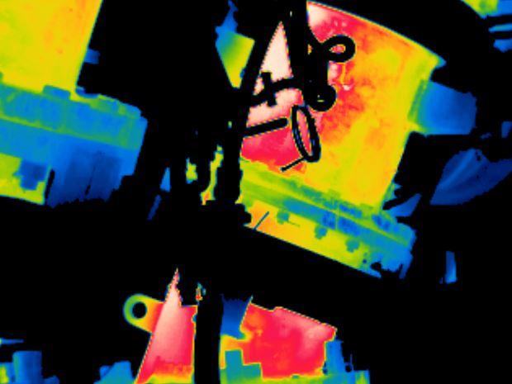

# **VT15 - DL XX / LE**

**20/01/2021**

# **MAX= 165ºC**

**13:07:56**

**MAPEAMENTO TÉRMICO – DOWNLEG**

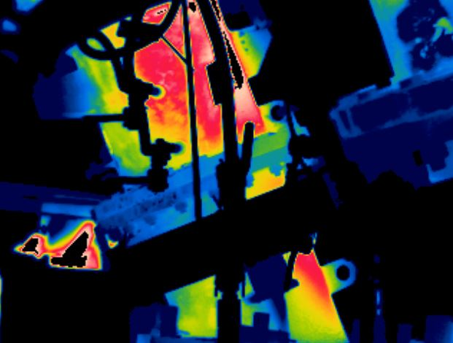

# **VT19 - DL XX / LD**

**20/01/2021**

# **MAX= 172ºC**

**13:08:54**

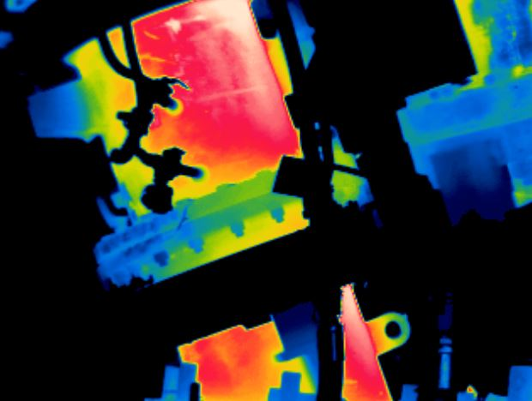

# **VT18 - DL XX / LD**

**20/01/2021**

# **MAX= 173ºC**

**13:08:38**

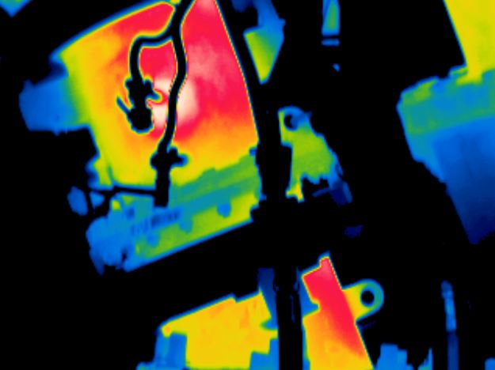

# **VT17 - DL XX / LD**

**20/01/2021**

# **MAX= 185ºC**

**13:08:22**

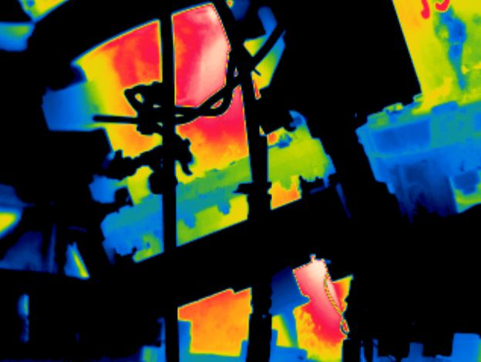

# **VT20 - DL XX / LD**

**20/01/2021**

# **MAX= 175ºC**

**13:09:08**

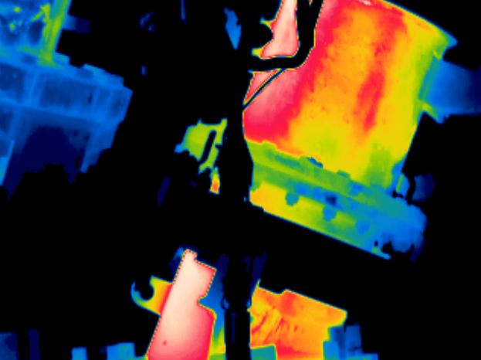

# **VT17 - DL XX / LE**

**20/01/2021**

# **MAX= 167ºC**

**13:08:30**

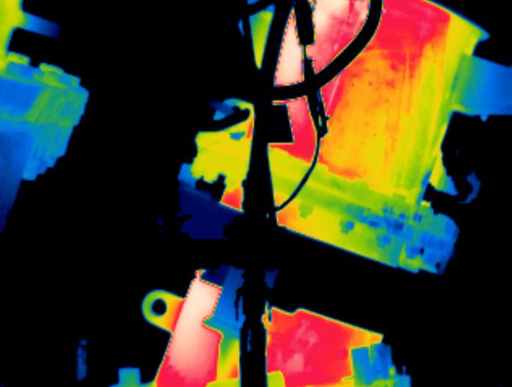

# **VT18 - DL XX / LE**

**20/01/2021**

# **MAX= 164ºC**

**13:08:46**

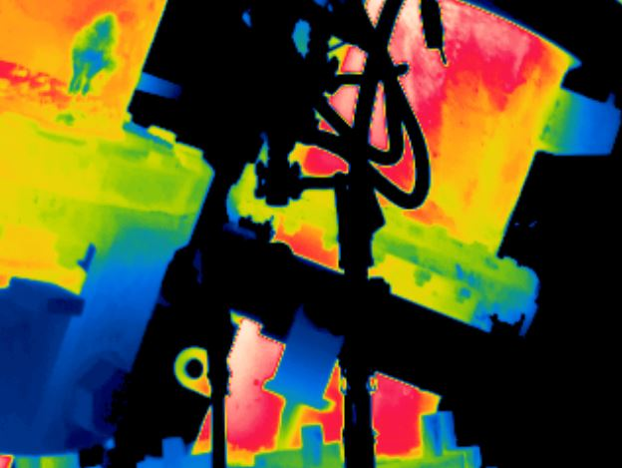

# **VT20 - DL XX / LE**

**20/01/2021**

# **MAX= 174ºC**

**13:09:18**

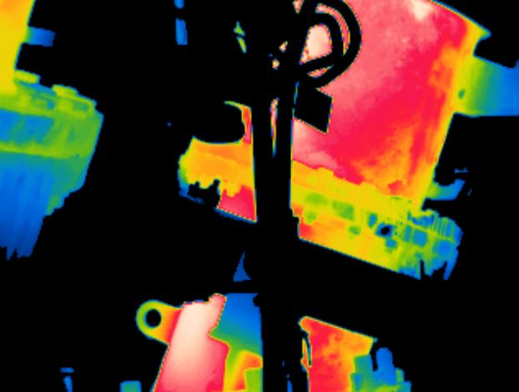

# **VT19 - DL XX / LE**

**20/01/2021**

# **MAX= 167ºC**

**13:09:00**

**MAPEAMENTO TÉRMICO – DOWNLEG**

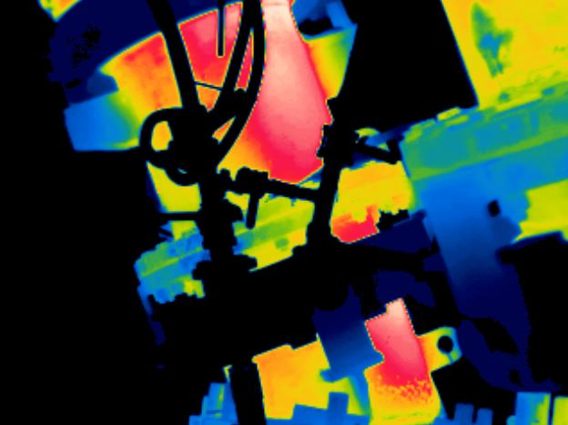

# **VT22 - DL XX / LD**

**20/01/2021**

# **MAX= 187ºC**

**13:09:44**

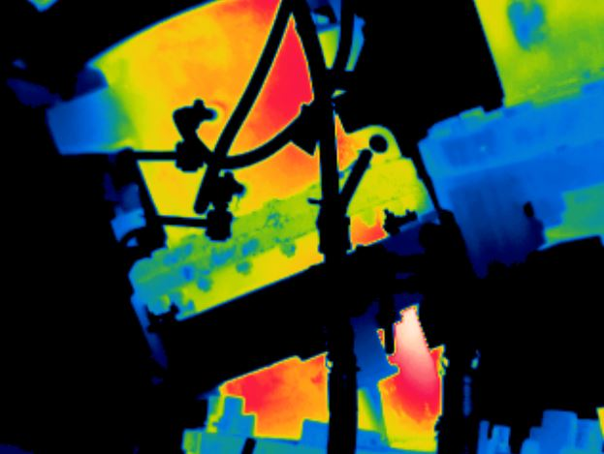

# **VT21 - DL XX / LD**

**20/01/2021**

# **MAX= 192ºC**

**13:09:26**

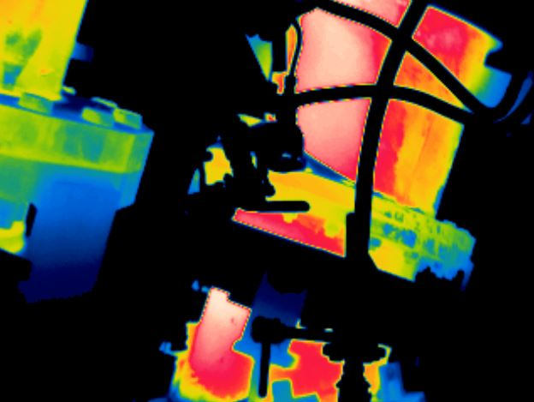

# **VT22 - DL XX / LE**

**20/01/2021**

# **MAX= 185ºC**

**13:09:54**

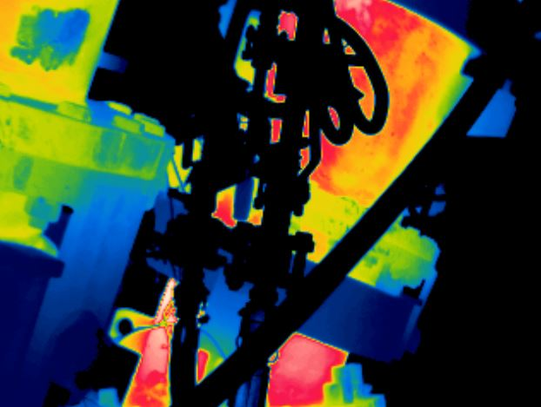

# **VT21 - DL XX / LE**

**20/01/2021**

# **MAX= 199ºC**

**13:09:38**

MAPAS TÉRMICOS – ALGARAVIZ JOELHO

**MAPEAMENTO TÉRMICO – ALGARAVIZ JOELHO**

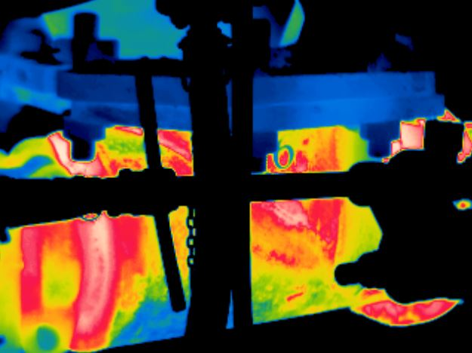

# **VT04 - JL M167 / LD**

**20/01/2021**

# **MAX= 234ºC**

**13:11:34**

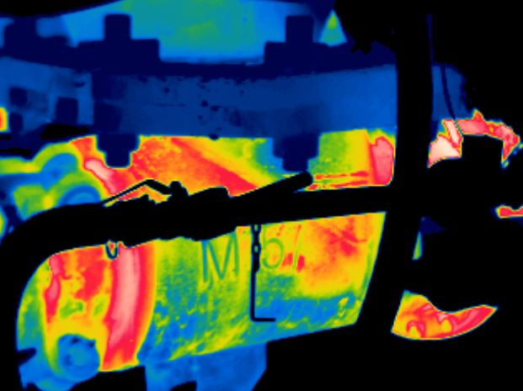

# **VT01 - JL M157 / LD**

**20/01/2021**

# **MAX= 224ºC**

**13:10:46**

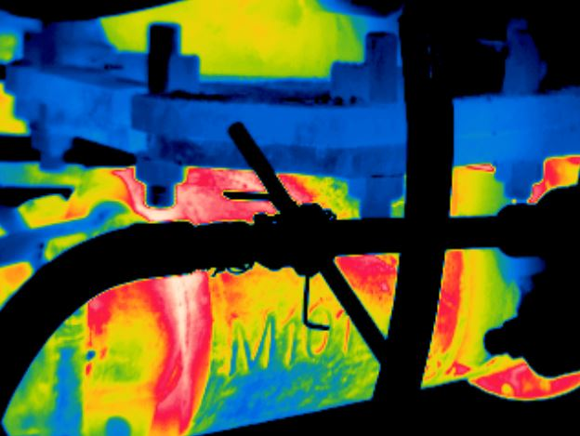

# **VT03 - JL M159 / LD**

**20/01/2021**

# **MAX= 239ºC**

**13:11:20**

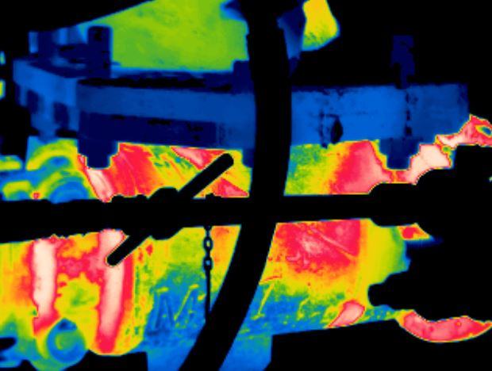

# **VT02 - JL 06 / LD**

**20/01/2021**

# **MAX= 223ºC**

**13:11:08**

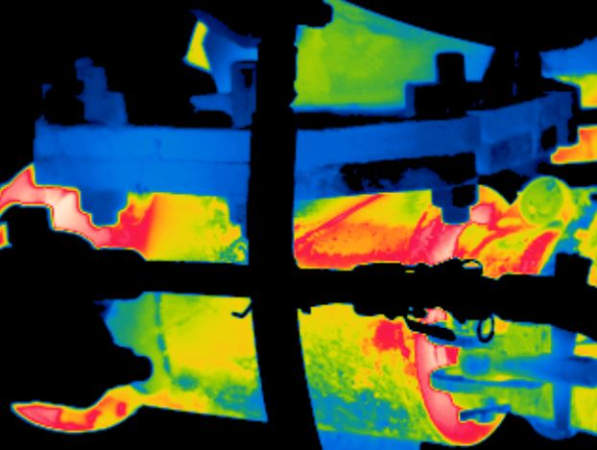

# **VT01 - JL M157 / LE**

**20/01/2021**

# **MAX= 230ºC**

**13:10:54**

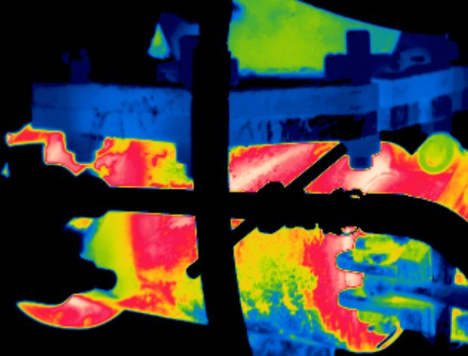

# **VT02 - JL 06 / LE**

**20/01/2021**

# **MAX= 230ºC**

**13:11:16**

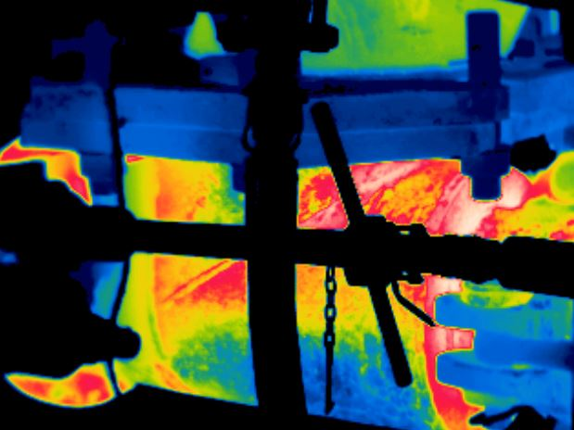

# **VT03 - JL M159 / LE**

**20/01/2021**

# **MAX= 245ºC**

**13:11:30**

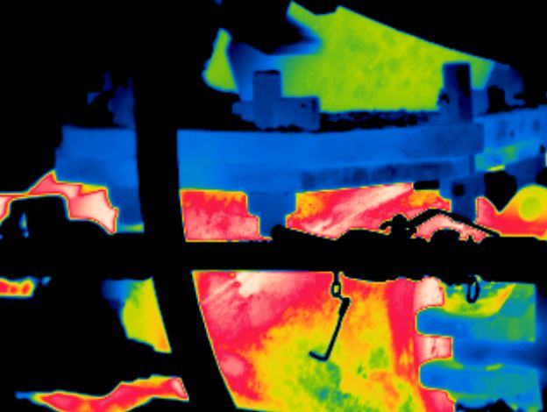

# **VT04 - JL M167 / LE**

**20/01/2021**

# **MAX= 239ºC**

**13:11:42**

**MAPEAMENTO TÉRMICO – ALGARAVIZ JOELHO**

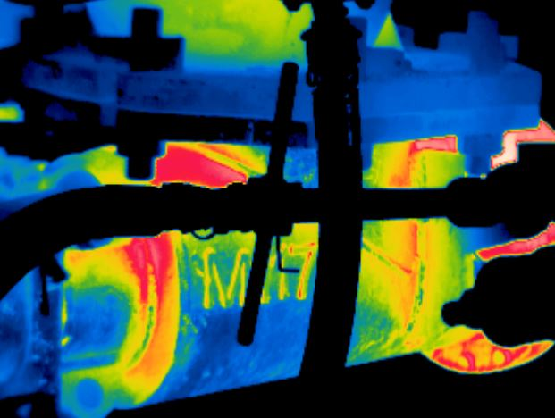

# **VT07 - JL M117 / LD**

**20/01/2021**

# **MAX= 226ºC**

**13:12:58**

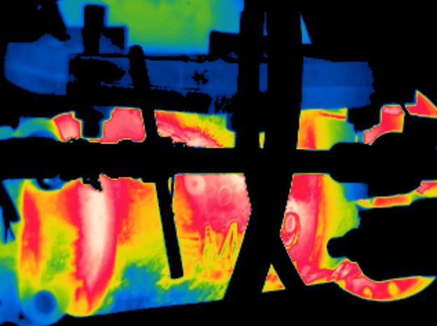

# **VT06 - JL 32M119 / LD**

**20/01/2021**

# **MAX= 221ºC**

**13:12:02**

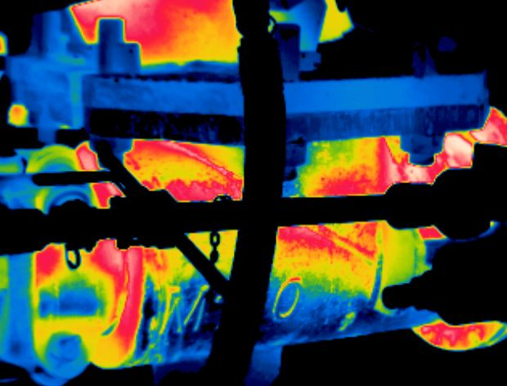

# **VT05 - JL M101 / LD**

**20/01/2021**

# **MAX= 226ºC**

**13:11:48**

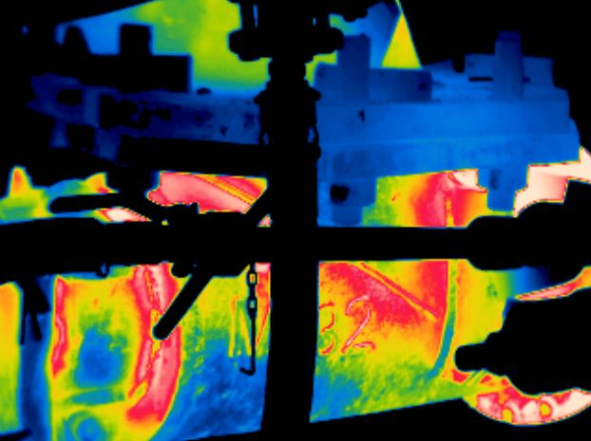

# **VT08 - JL M132 / LD**

**20/01/2021**

# **MAX= 212ºC**

**13:13:12**

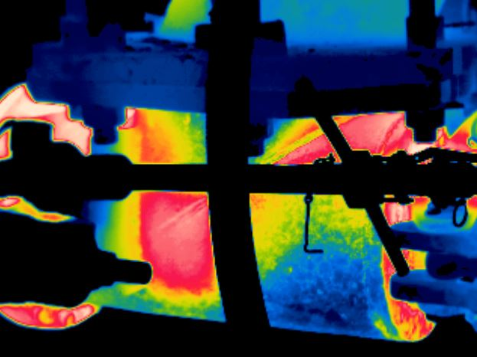

# **VT08 - JL M132 / LE**

**20/01/2021**

# **MAX= 204ºC**

**13:13:18**

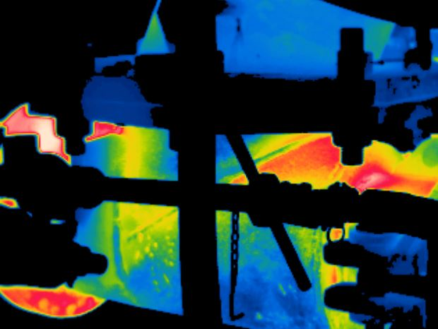

# **VT07 - JL M117 / LE**

**20/01/2021**

# **MAX= 217ºC**

**13:13:04**

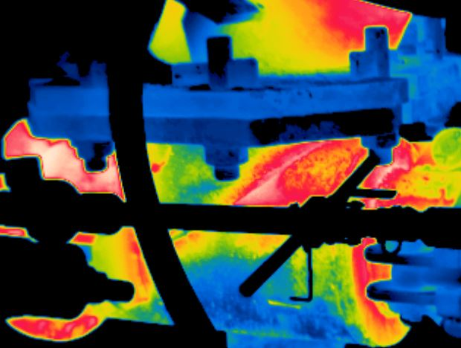

# **VT05 - JL M101 / LE**

**20/01/2021**

# **MAX= 228ºC**

**13:11:54**

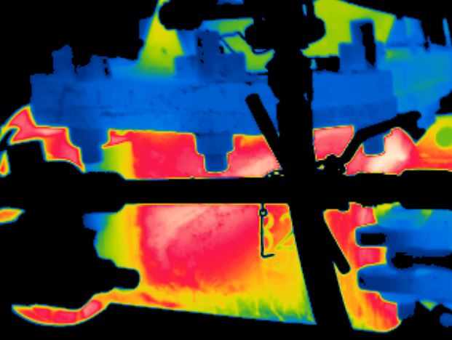

# **VT06 - JL 32M119 / LE**

**20/01/2021**

# **MAX= 219ºC**

**13:12:10**

**MAPEAMENTO TÉRMICO – ALGARAVIZ JOELHO**

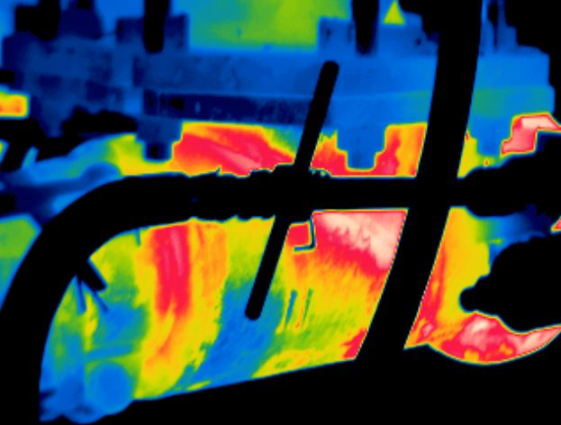

# **VT09 - JL 11 / LD**

**20/01/2021**

# **MAX= 219ºC**

**13:13:24**

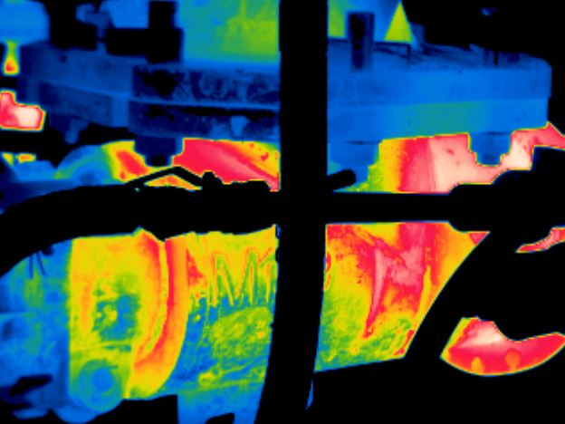

# **VT10 - JL M164 / LD**

**20/01/2021**

# **MAX= 219ºC**

**13:13:40**

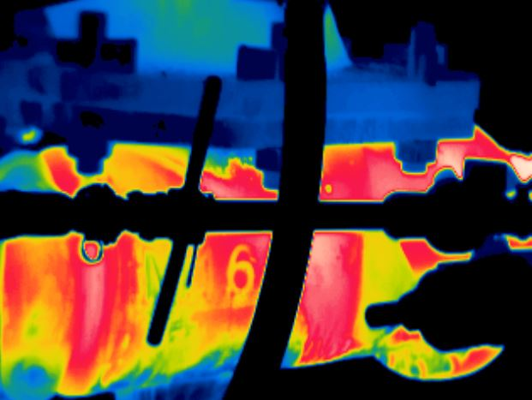

# **VT11 - JL M165 / LD**

**20/01/2021**

# **MAX= 225ºC**

**13:13:52**

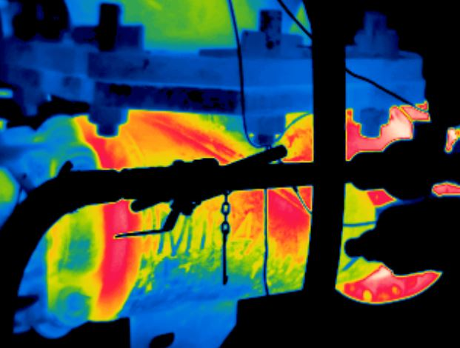

# **VT12 - JL M168 / LD**

**20/01/2021**

# **MAX= 232ºC**

**13:14:04**

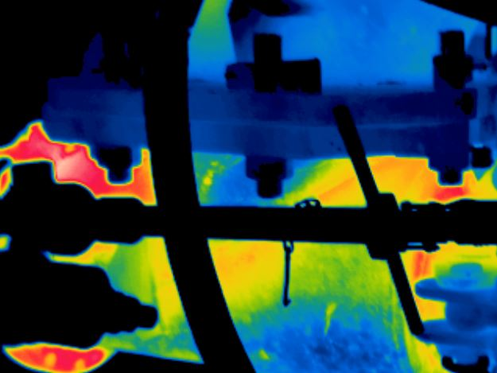

# **VT12 - JL M168 / LE**

**20/01/2021**

# **MAX= 220ºC**

**13:14:12**

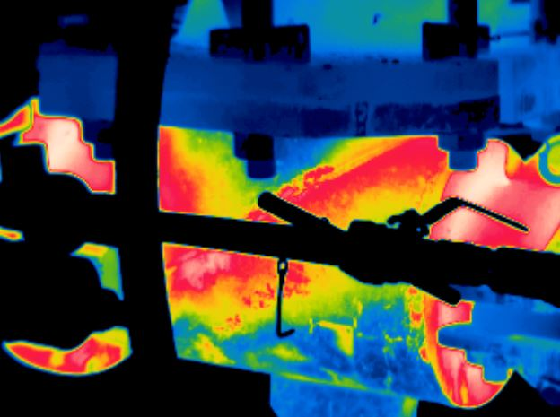

# **VT11 - JL M165 / LE**

**20/01/2021**

# **MAX= 210ºC**

**13:13:58**

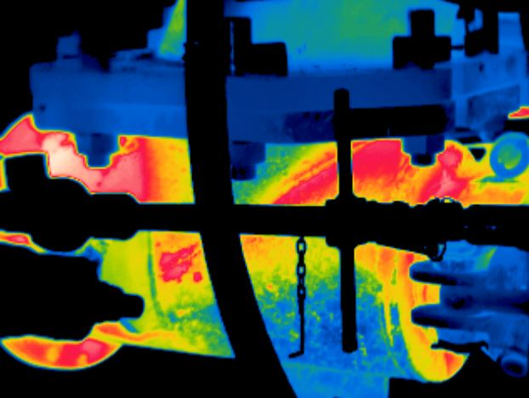

# **VT10 - JL M164 / LE**

**20/01/2021**

# **MAX= 212ºC**

**13:13:46**

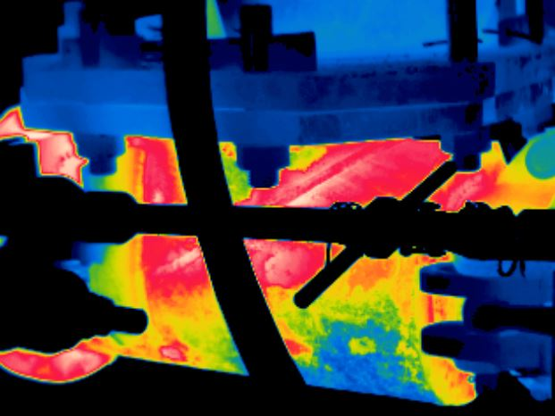

# **VT09 - JL 11 / LE**

**20/01/2021**

# **MAX= 210ºC**

**13:13:34**

**MAPEAMENTO TÉRMICO – ALGARAVIZ JOELHO**

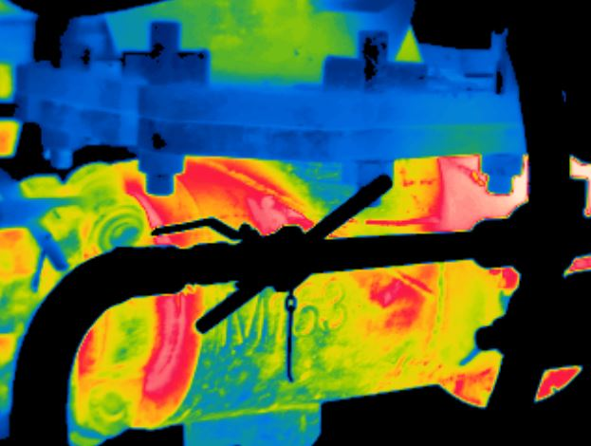

# **VT13 - JL M123 / LD**

**20/01/2021**

# **MAX= 252ºC**

**13:14:18**

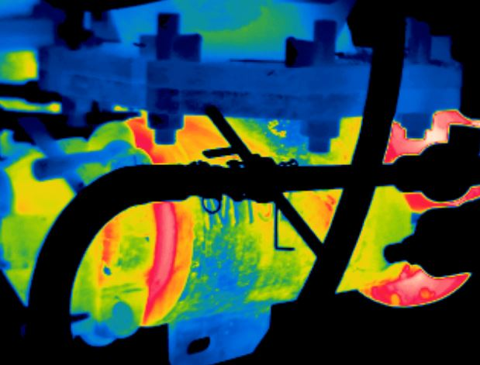

# **VT14 - JL M152 / LD**

**20/01/2021**

# **MAX= 239ºC**

**13:14:32**

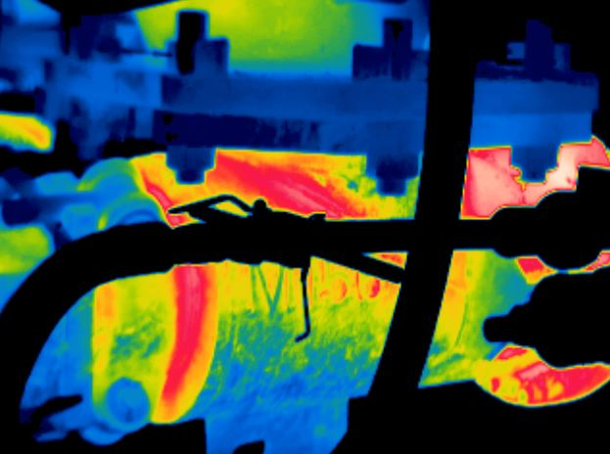

# **VT15 - JL M156 / LD**

**20/01/2021**

# **MAX= 224ºC**

**13:14:46**

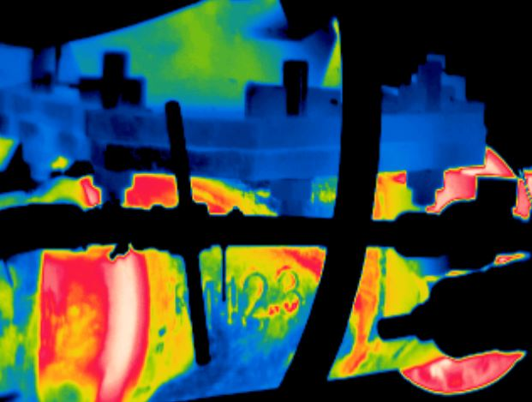

# **VT16 - JL M163 / LD**

**20/01/2021**

# **MAX= 211ºC**

**13:14:58**

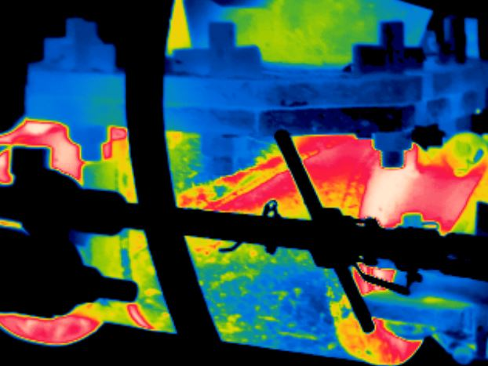

# **VT16 - JL M163 / LE**

**20/01/2021**

# **MAX= 212ºC**

**13:15:04**

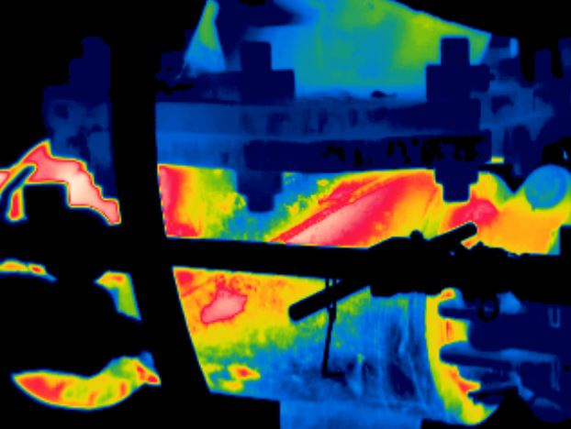

# **VT15 - JL M156 / LE**

**20/01/2021**

# **MAX= 223ºC**

**13:14:54**

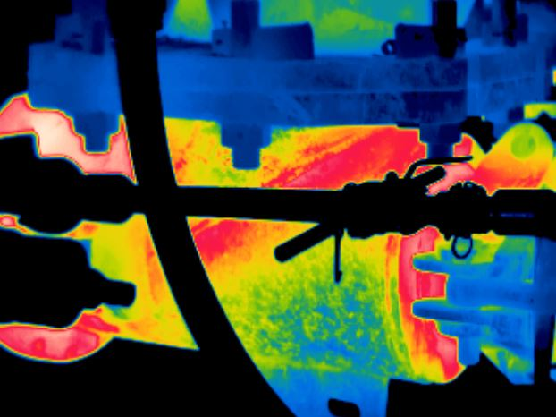

# **VT14 - JL M152 / LE**

**20/01/2021**

# **MAX= 226ºC**

**13:14:42**

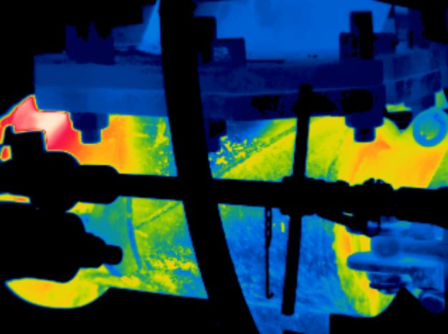

# **VT13 - JL M123 / LE**

**20/01/2021**

# **MAX= 281ºC**

**13:14:26**

**MAPEAMENTO TÉRMICO – ALGARAVIZ JOELHO**

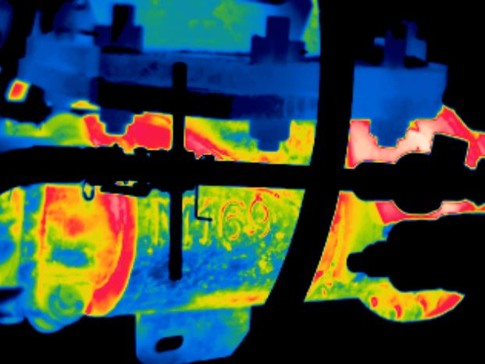

# **VT17 - JL 24M114 / LD**

**20/01/2021**

# **MAX= 213ºC**

**13:15:12**

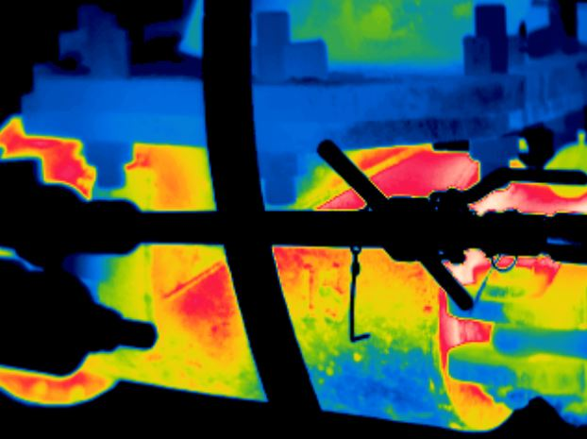

# **VT18 - JL 15M159 / LD**

**20/01/2021**

# **MAX= 232ºC**

**13:15:26**

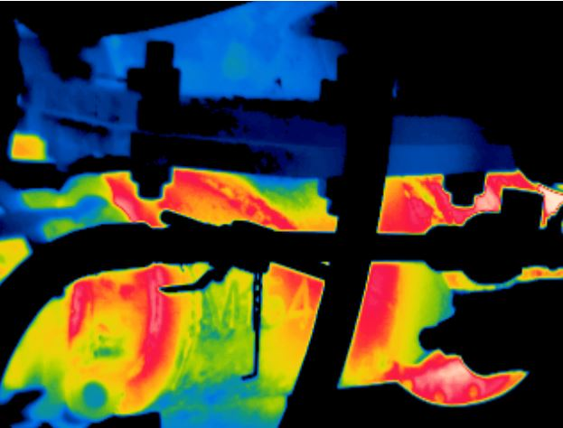

# **VT19 - JL M154 / LD**

**20/01/2021**

# **MAX= 200ºC**

**13:15:40**

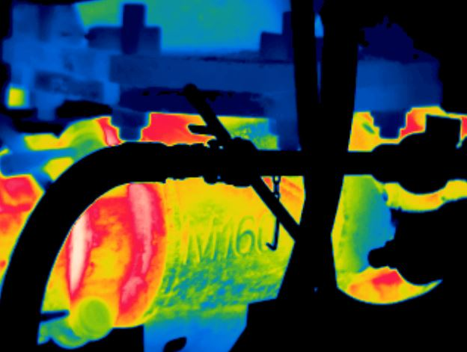

# **VT20 - JL M160 / LD**

**20/01/2021**

# **MAX= 226ºC**

**13:16:40**

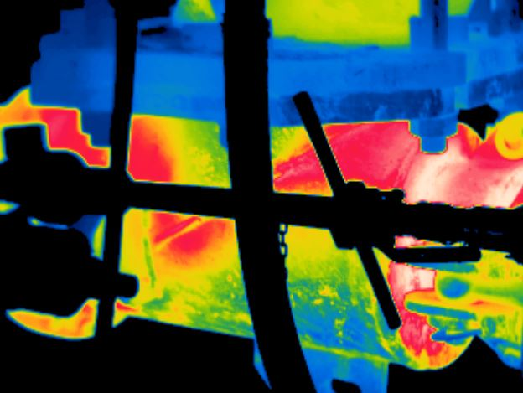

# **VT20 - JL M160 / LE**

**20/01/2021**

# **MAX= 226ºC**

**13:16:48**

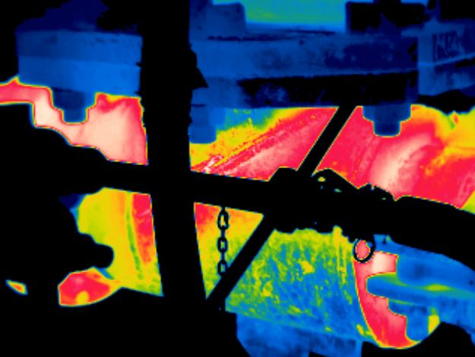

# **VT19 - JL M154 / LE**

**20/01/2021**

# **MAX= 216ºC**

**13:16:36**

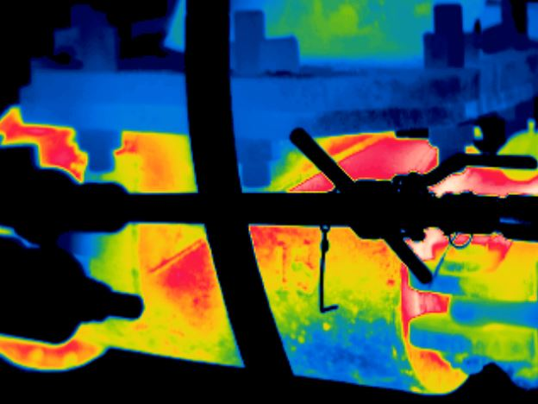

# **VT18 - JL 15M159 / LE**

**20/01/2021**

# **MAX= 235ºC**

**13:15:36**

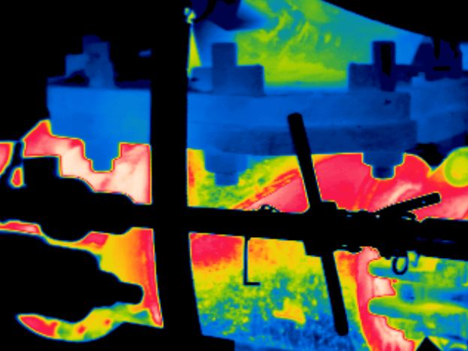

# **VT17 - JL M114 / LE**

**20/01/2021**

# **MAX= 211ºC**

**13:15:18**

**MAPEAMENTO TÉRMICO – ALGARAVIZ JOELHO**

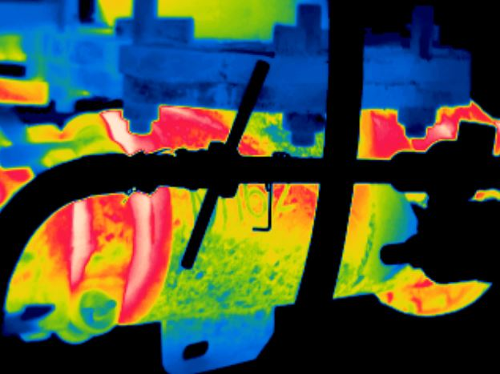

# **VT21 - JL M162 / LD**

**20/01/2021**

# **MAX= 215ºC**

**13:16:54**

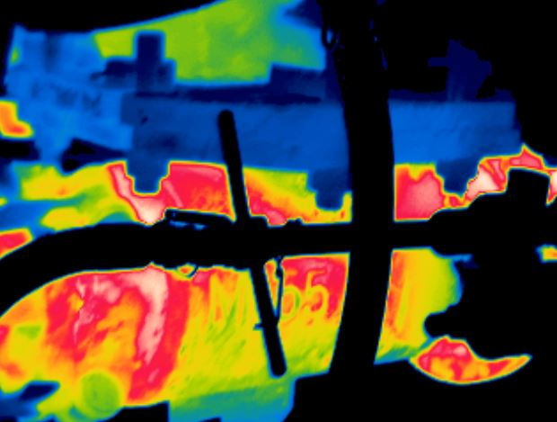

# **VT22 - JL M155 / LD**

**20/01/2021**

# **MAX= 210ºC**

**13:17:06**

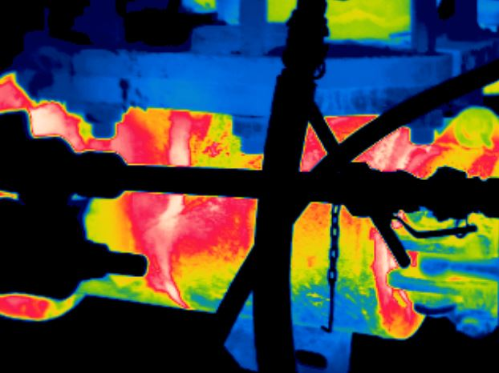

# **VT22 – JL M155 / LE**

**20/01/2021**

# **MAX= 217ºC**

**13:17:22**

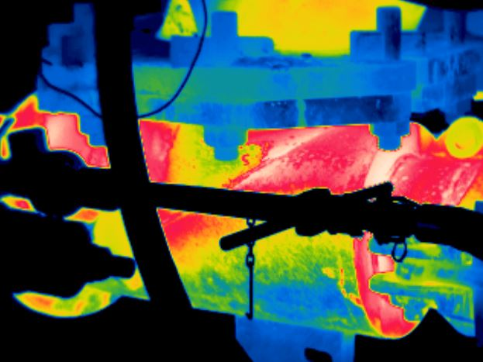

# **VT21 - JL M162 / LE**

**20/01/2021**

# **MAX= 228ºC**

**13:17:00**

MAPAS TÉRMICOS – ALGARAVIZ NARIZ

**MAPEAMENTO TÉRMICO – ALGARAVIZ NARIZ**

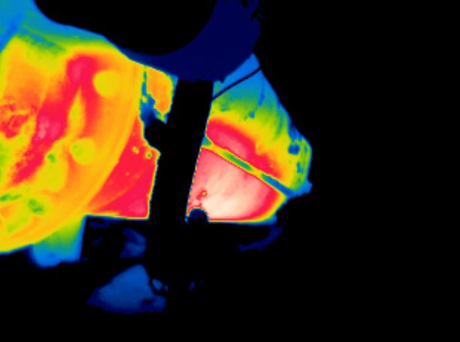

# **VT04 - NR M167 / LD**

**20/01/2021**

# **MAX= 260ºC**

**13:19:16**

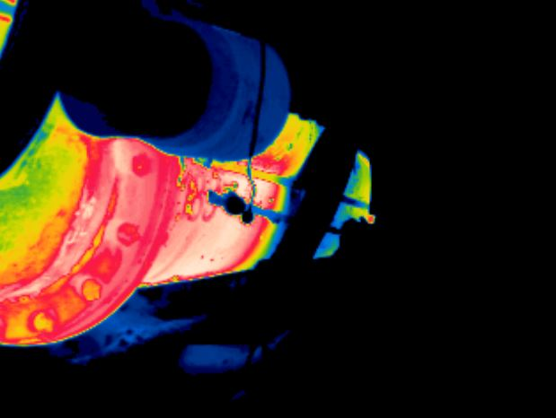

# **VT01 - NR M157 / LD**

**20/01/2021**

# **MAX= 226ºC**

**13:17:46**

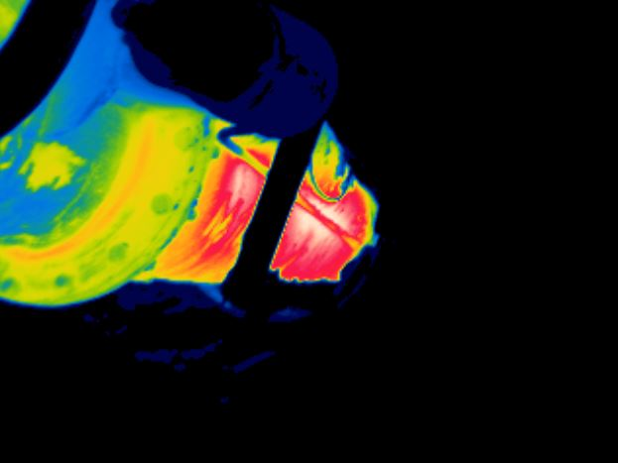

# **VT03 - NR M159 / LD**

**20/01/2021**

# **MAX= 330ºC**

**13:18:50**

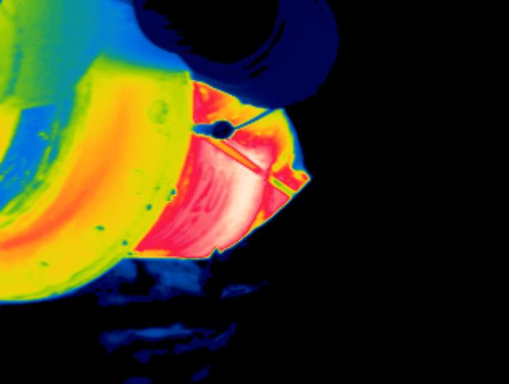

# **VT02 - NR 06 / LD**

**20/01/2021**

# **MAX= 298ºC**

**13:18:16**

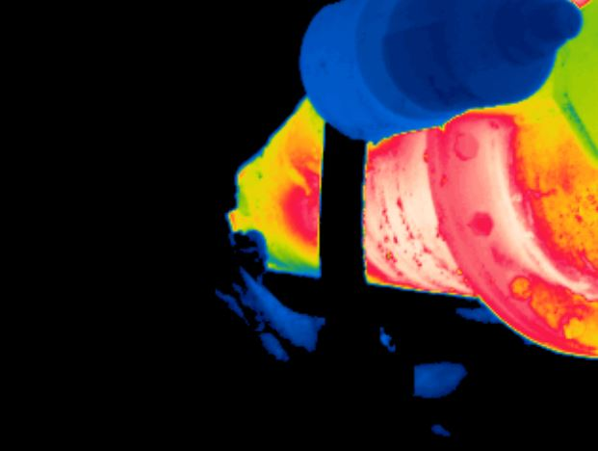

# **VT01 - NR M157 / LE**

**20/01/2021**

# **MAX= 237ºC**

**13:17:58**

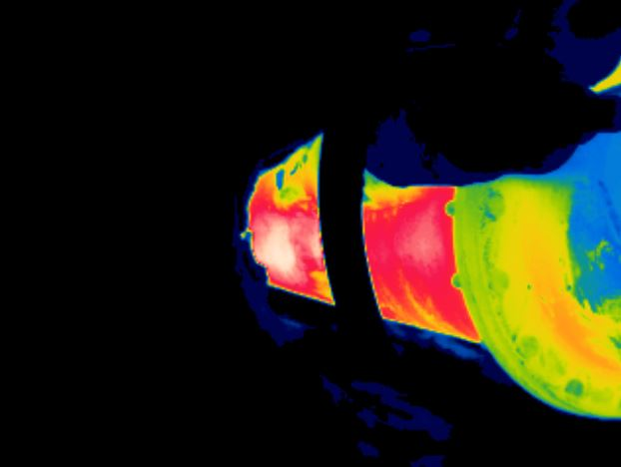

# **VT02 - NR 06 / LE**

**20/01/2021**

# **MAX= 306ºC**

**13:18:24**

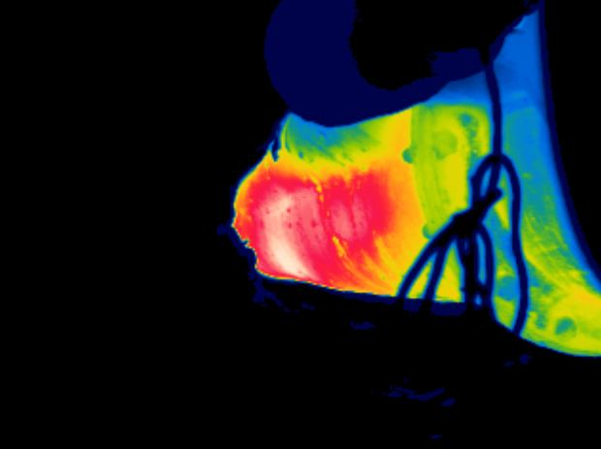

# **VT03 - NR M159 / LE**

**20/01/2021**

# **MAX= 317ºC**

**13:18:58**

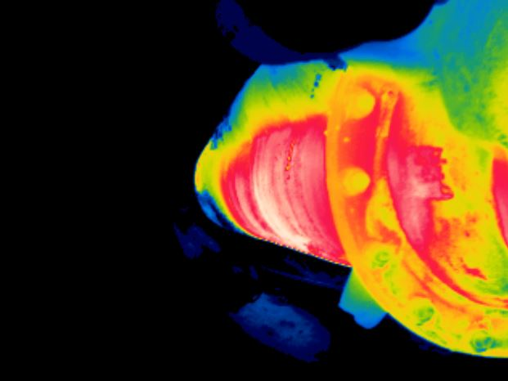

# **VT04 - NR M167 / LE**

**20/01/2021**

# **MAX= 262ºC**

**13:19:22**

**MAPEAMENTO TÉRMICO – ALGARAVIZ NARIZ**

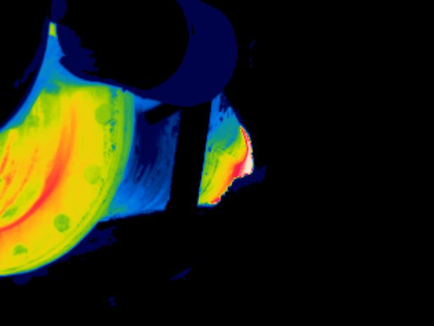

# **VT06 - NR 32M119 / LD**

**20/01/2021**

# **MAX= 293ºC**

**13:20:00**

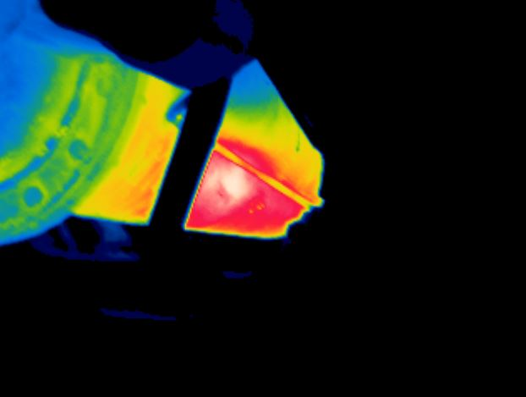

# **VT07 - NR M117 / LD**

**20/01/2021**

# **MAX= 335ºC**

**13:20:24**

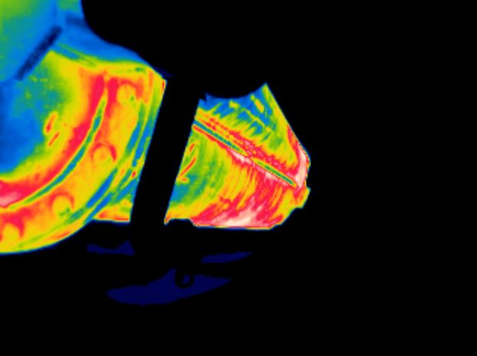

# **VT05 - NR M101 / LD**

**20/01/2021**

# **MAX= 203ºC**

**13:19:36**

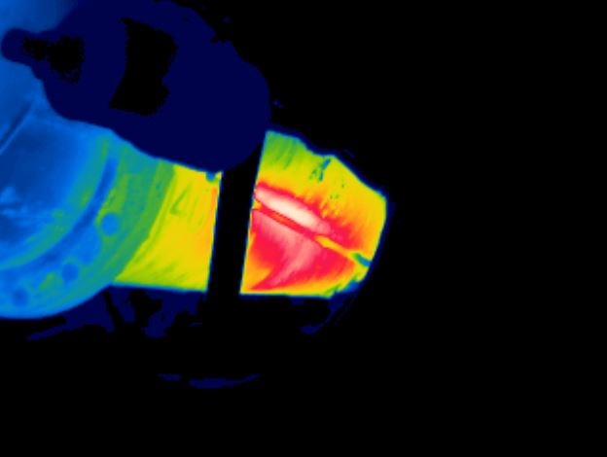

# **VT08 - NR M132 / LD**

**20/01/2021**

# **MAX= 380ºC**

**13:20:50**

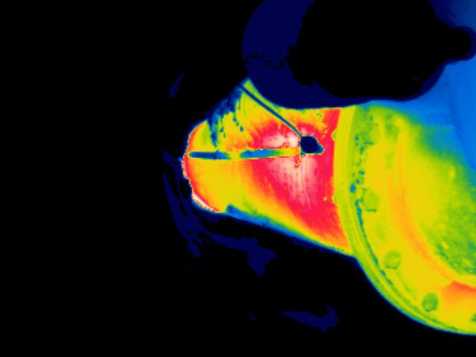

# **VT06 - NR 32M119 / LE**

**20/01/2021**

# **MAX= 298ºC**

**13:20:06**

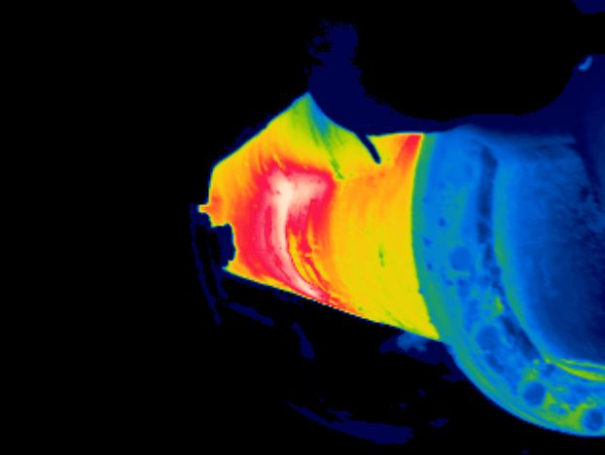

# **VT08 - NR M132 / LE**

**20/01/2021**

# **MAX= 315ºC**

**13:20:58**

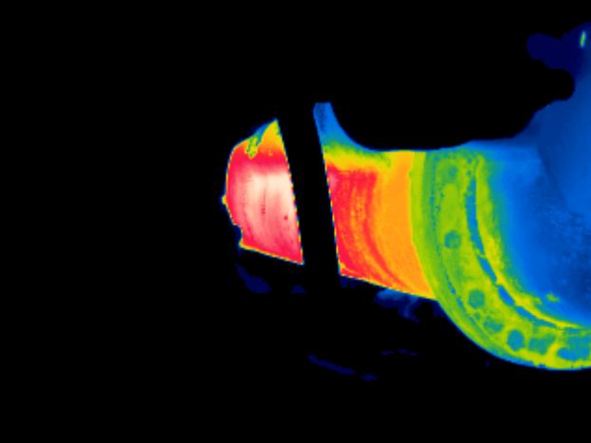

# **VT07 - NR M117 / LE**

**20/01/2021**

# **MAX= 293ºC**

**13:20:32**

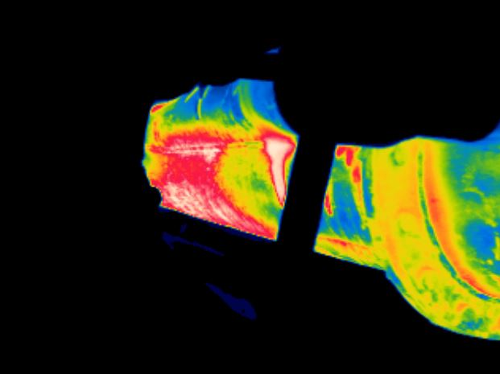

# **VT05 - NR M101 / LE**

**20/01/2021**

# **MAX= 262ºC**

**13:19:44**

**MAPEAMENTO TÉRMICO – ALGARAVIZ NARIZ**

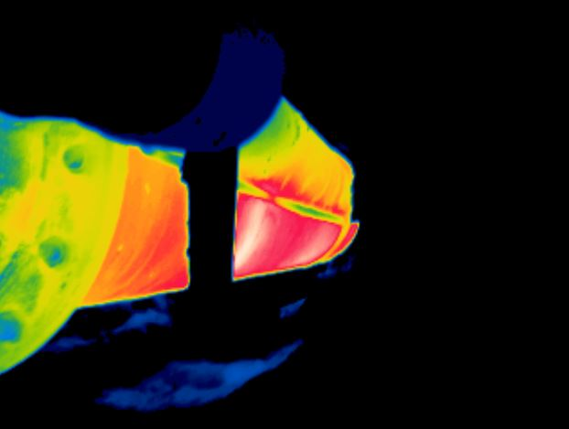

# **VT09 - NR 11 / LD**

**20/01/2021**

# **MAX= 318ºC**

**13:21:30**

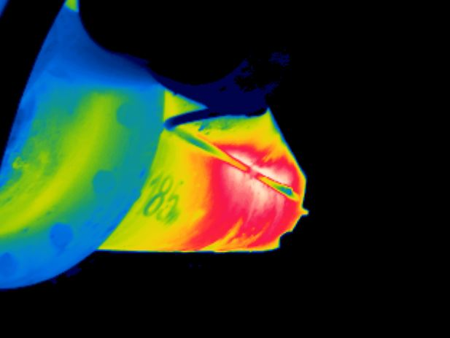

# **VT10 - NR M164 / LD**

**20/01/2021**

# **MAX= 350ºC**

**13:22:40**

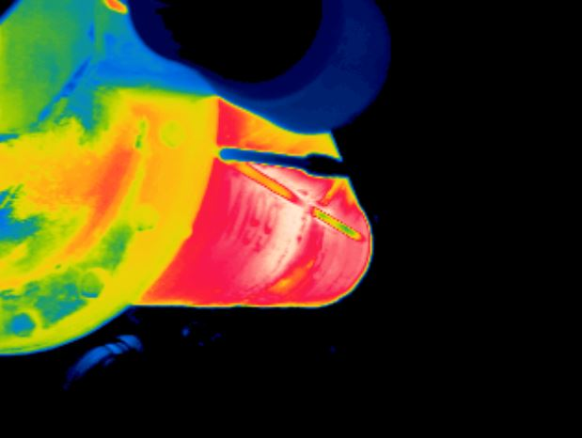

# **VT11 - NR M165 / LD**

**20/01/2021**

# **MAX= 285ºC**

**13:23:00**

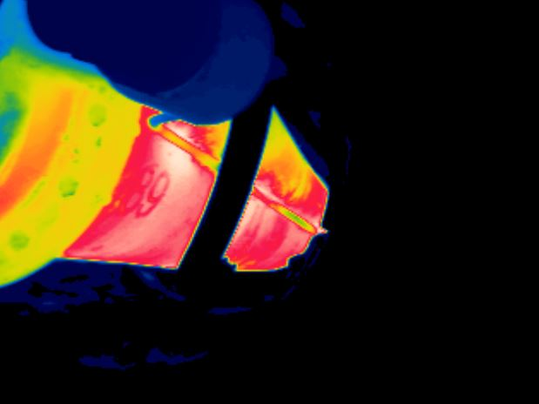

# **VT12 - NR M168 / LD**

**20/01/2021**

# **MAX= 292ºC**

**13:23:24**

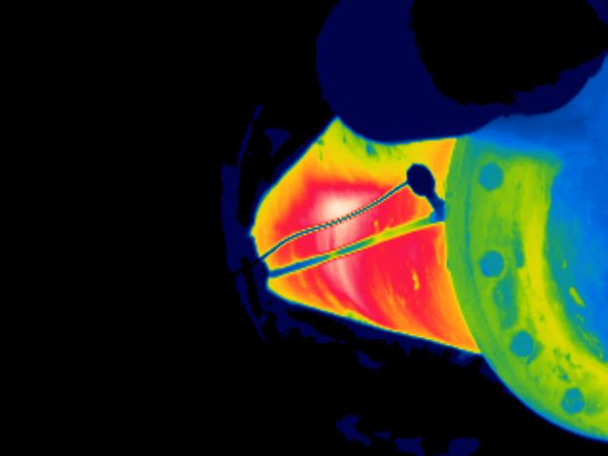

# **VT12 - NR M168 / LE**

**20/01/2021**

# **MAX= 337ºC**

**13:23:40**

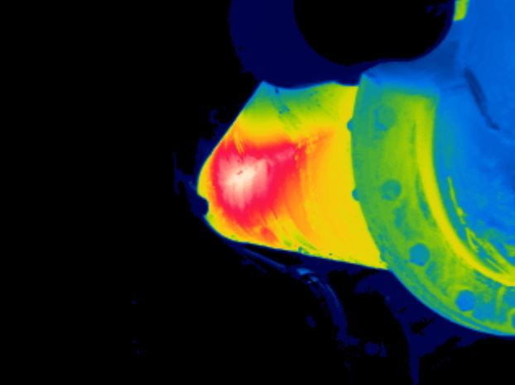

# **VT11 - NR M165 / LE**

**20/01/2021**

# **MAX= 342ºC**

**13:23:14**

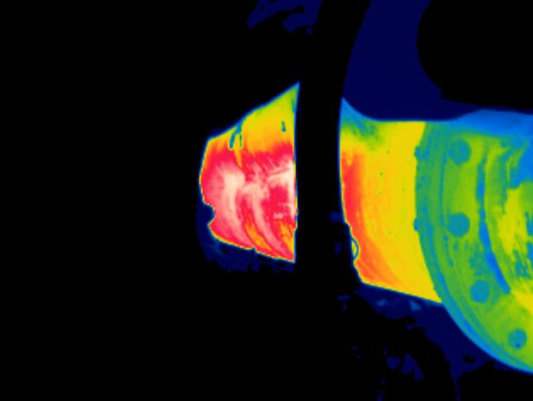

# **VT10 - NR M164 / LE**

**20/01/2021**

# **MAX= 309ºC**

**13:22:48**

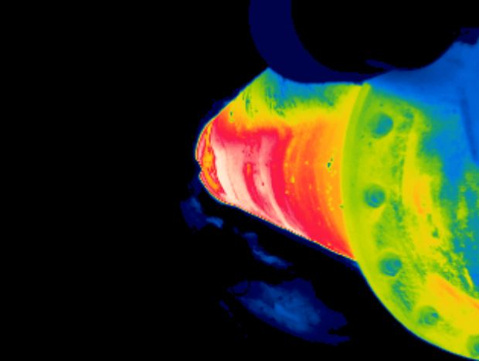

# **VT09 - NR 11 / LE**

**20/01/2021**

# **MAX= 288ºC**

**13:21:36**

**MAPEAMENTO TÉRMICO – ALGARAVIZ NARIZ**

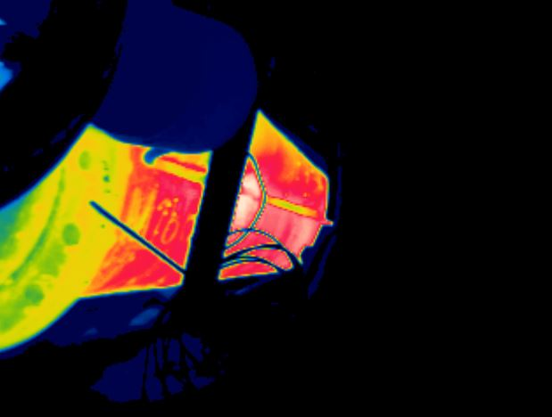

# **VT13 - NR M123 / LD**

**20/01/2021**

# **MAX= 294ºC**

**13:24:00**

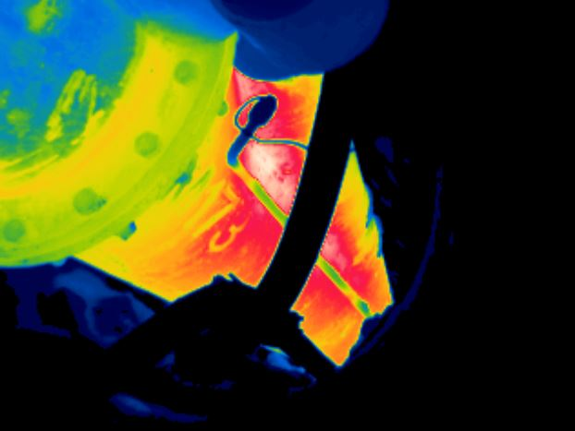

# **VT14 - NR M152 / LD**

**20/01/2021**

# **MAX= 341ºC**

**13:24:52**

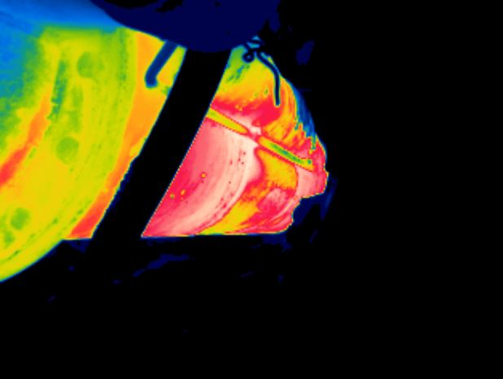

# **VT15 - NR M156 / LD**

**22/01/2021**

# **MAX= 261ºC**

**10:16:42**

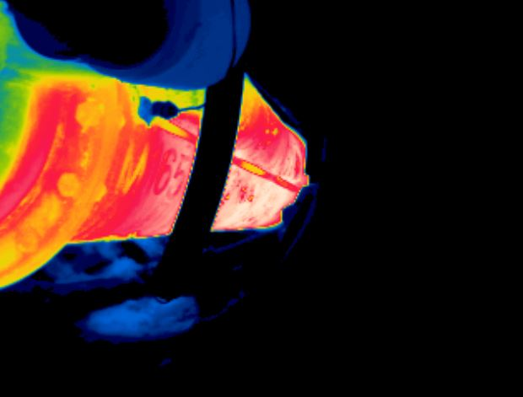

# **VT16 - NR M163 / LD**

**20/01/2021**

# **MAX= 254ºC**

**13:25:36**

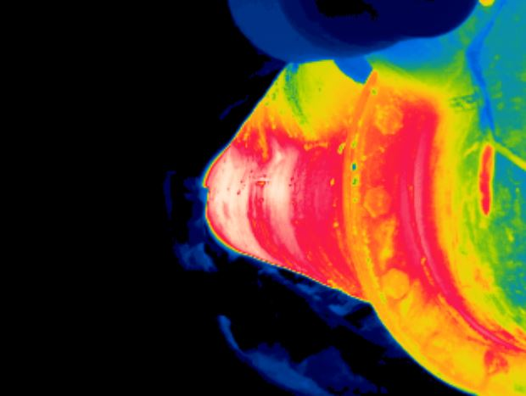

# **VT16 - NR M163 / LE**

**20/01/2021**

# **MAX= 261ºC**

**13:25:44**

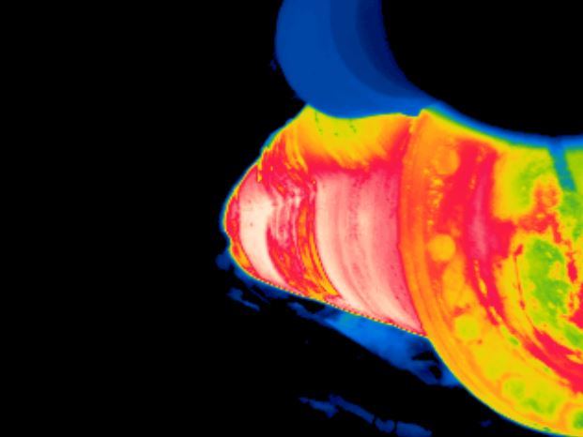

# **VT15 - NR M156 / LE**

**20/01/2021**

# **MAX= 245ºC**

**13:25:20**

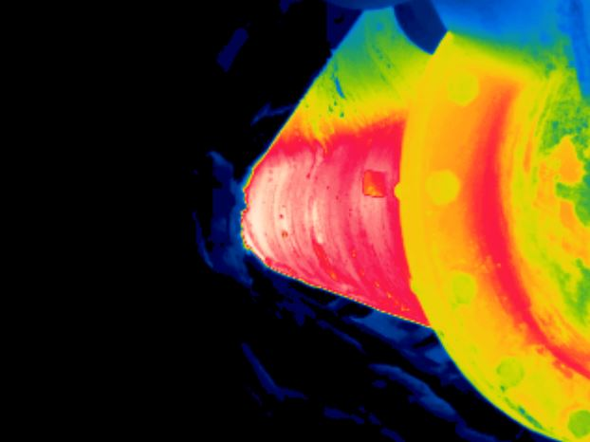

# **VT14 - NR M152 / LE**

**20/01/2021**

# **MAX= 270ºC**

**13:24:58**

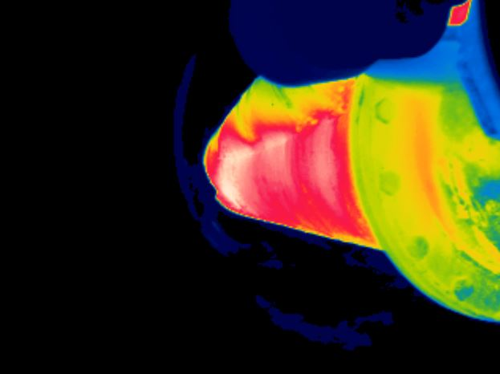

# **VT13 - NR M123 / LE**

**20/01/2021**

# **MAX= 299ºC**

**13:24:16**

**MAPEAMENTO TÉRMICO – ALGARAVIZ NARIZ**

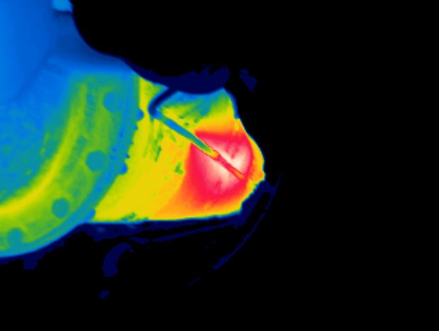

# **VT18 - NR 15M159 / LD**

**20/01/2021**

# **MAX= 360ºC**

**13:26:26**

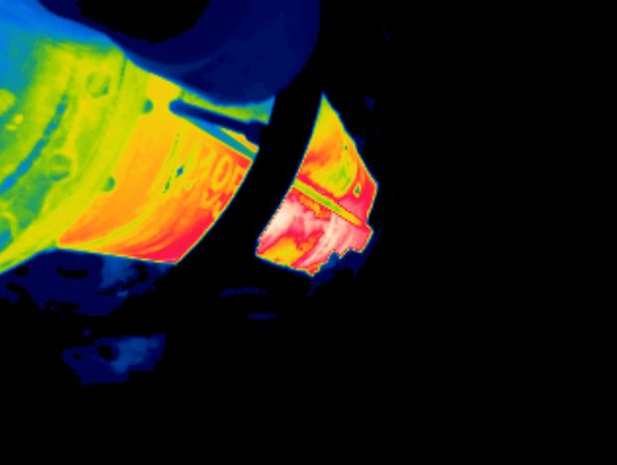

# **VT17 - NR 24M114 / LD**

**20/01/2021**

# **MAX= 291ºC**

**13:26:00**

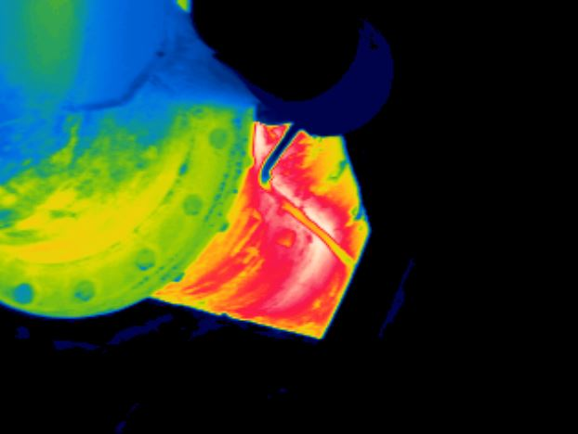

# **VT19 - NR M154 / LD**

**20/01/2021**

# **MAX= 319ºC**

**13:26:54**

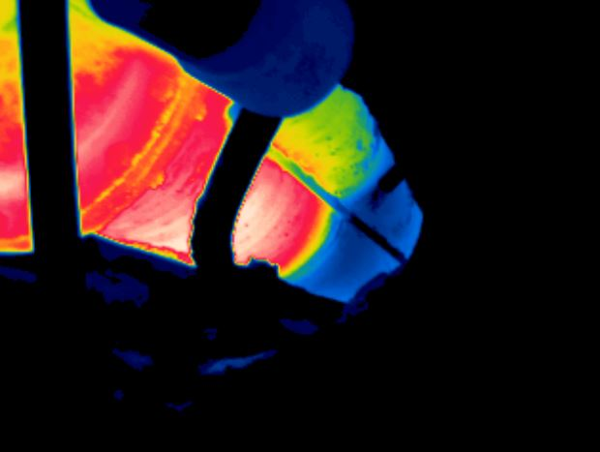

# **VT20 - NR M160 / LD**

**20/01/2021**

# **MAX= 217ºC**

**13:27:34**

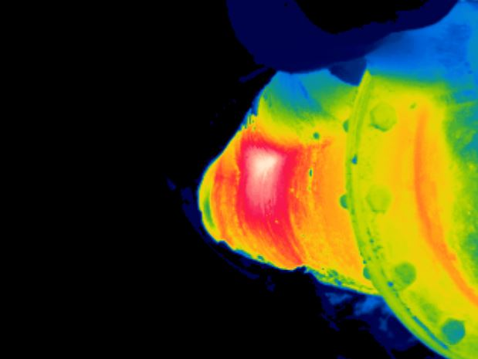

# **VT18 - NR 15M159 / LE**

**20/01/2021**

# **MAX= 312ºC**

**13:26:36**

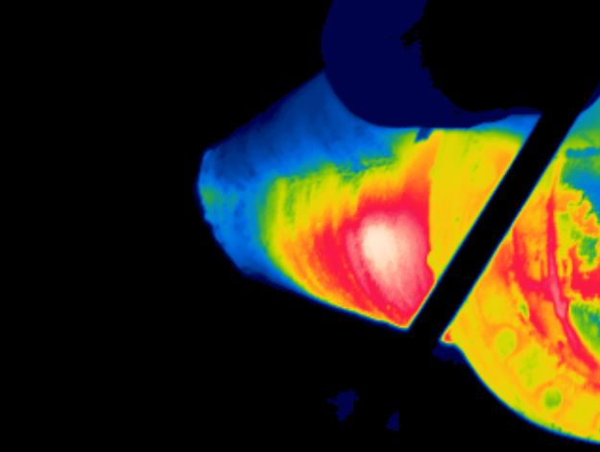

# **VT20 - NR M160 / LE**

**20/01/2021**

# **MAX= 236ºC**

**13:27:40**

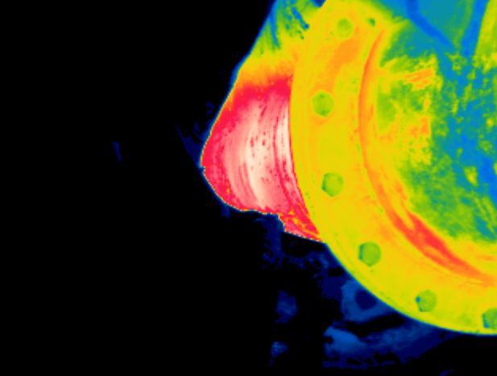

# **VT19 - NR M154 / LE**

**20/01/2021**

# **MAX= 272ºC**

**13:27:00**

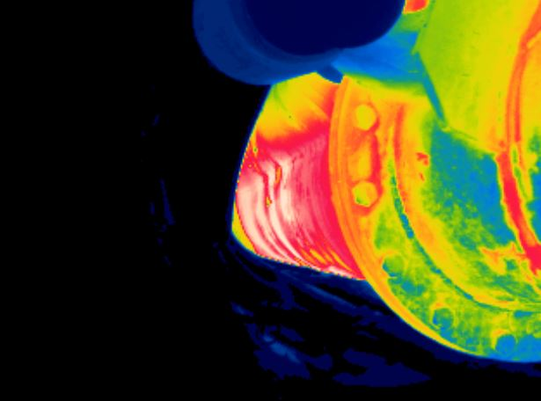

# **VT17 - NR M114 / LE**

**20/01/2021**

# **MAX= 259ºC**

**13:26:12**

**MAPEAMENTO TÉRMICO – ALGARAVIZ NARIZ**

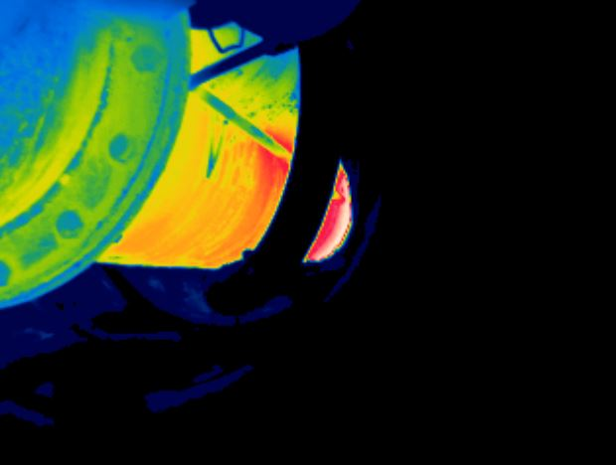

# **VT21 - NR M162 / LD**

**20/01/2021**

# **MAX= 326ºC**

**13:27:54**

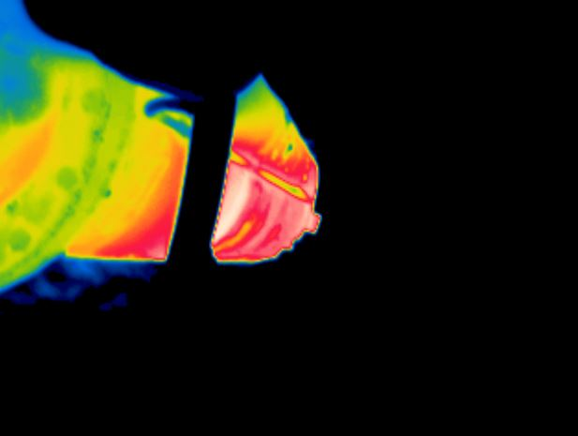

# **VT22 - NR M155 / LD**

**20/01/2021**

# **MAX= 278ºC**

**13:28:46**

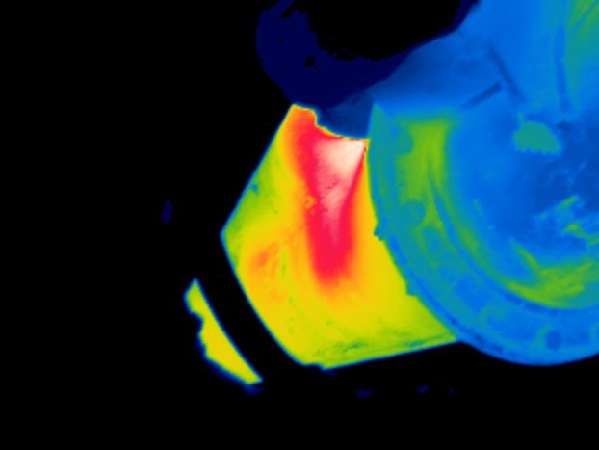

# **VT21 - NR M162 / LE**

**20/01/2021**

# **MAX= 396ºC**

**13:28:22**

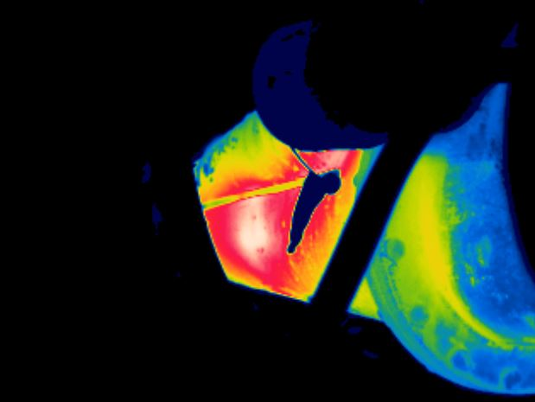

# **VT22 - NR M155 / LE**

**20/01/2021**

# **MAX= 334ºC**

**13:29:24**